March 17, 2014

President and Members of City Council
City of Pittsburgh
510 City-County Building 414 Grant Street
Pittsburgh, PA 15219

Dear President and Members of Council:

This letter is to inform you that I have made the following appointment as a member of the Board of Directors of the Allegheny County Sanitary Authority, pending your confirmation.

Greg Jones
930 Davis Avenue
Pittsburgh, PA 15212

Thank you for your cooperation.

Sincerely,

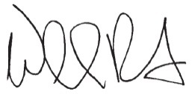

William Peduto
Mayor

