November 22, 2021

President and Members
Pittsburgh City Council
City of Pittsburgh

Dear President and Members:
We submit herewith a Resolution authorizing the Director of the Department of Finance to enter into a License Agreement with Giant Eagle, Inc., to allow the performance of pre-development due diligence investigations and site inspections on designated City property in order to facilitate the construction of a GetGo café and market in the Homewood and Larimer community.

Therefore, we recommend this Resolution for your approval.

Sincerely,
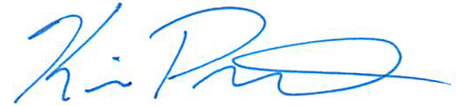

Kevin Pawlos
Acting Director/Treasurer

KP/AP/BJ
Attachments

cc: Councilman R. Daniel Lavelle, Finance Chair – City Council
Brenda F. Pree - City Clerk

