March 17, 2014

President and Members of City Council
City of Pittsburgh
510 City-County Building 414 Grant Street
Pittsburgh, PA 15219

Dear President and Members of Council:

This letter is to inform you that I have made the following appointment as a member of the Pittsburgh Planning Commission, pending your confirmation.

Jennifer Askey
2408 Beaufort Avenue
Pittsburgh, PA 15226

Thank you for your cooperation.

Sincerely,

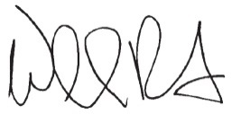

William Peduto
Mayor

