March 17, 2014

President and Members of City Council
City of Pittsburgh
510 City-County Building 414 Grant Street
Pittsburgh, PA 15219

Dear President and Members of Council:

This letter is to inform you that I have made the following appointment as a member of the Board of Directors of the Housing Authority of the City of Pittsburgh, pending your confirmation.

Enid Miller
123 Conover Road
Pittsburgh, PA 15208

Thank you for your cooperation.

Sincerely,

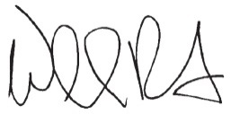

William Peduto
Mayor

