April 1, 2022

President and Members
City Council
City of Pittsburgh

Dear President and Members:

We submit for your consideration a Resolution authorizing the Mayor and the Director of Parks and Recreation to enter on behalf of the City of Pittsburgh into a Grant Agreement with Chester County Intermediate Unit (CCIU), for the purpose of receiving funds in the amount of EIGHTY THOUSAND DOLLARS ($80,000) that will be used to purchase technology and other materials needed for the facilitation of computer science learning experiences for children attending educational programs at select City of Pittsburgh recreation centers. Said funds shall be deposited into the following Grant Trust Account, 5029400382.45505.00 and expenses paid from the same Grant Trust Fund Account Number 5029400382.50000.00.

Your favorable consideration of this resolution is hereby requested.

Very truly yours,

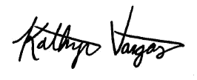

Kathryn Vargas
Acting Director

KV/LH

Attachment

