October 8, 2021

The Honorable President and Members of Council
City County Building, 5th Floor
Pittsburgh, PA 15219

Dear President and Members of Council:

Attached is a proposed resolution authorizing the Mayor and Director of the Department of City Panning to enter into an Agreement or Agreements with the U.S. Department of Agriculture Natural Resources Conservation Service to support a municipal composting program feasibility study.

Your favorable consideration of this proposed Resolution is appreciated.

Sincerely,

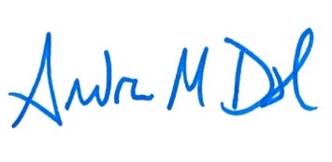
Andrew Dash, AICP
Planning Director

