CITY OF PITTSBURGH

***Office of Management and Budget***  
  
***William Peduto, Mayor*** ***Kevin Pawlos, Director***

November 24, 2021

The Honorable President and Members of Council

5th Floor, City-County Building

414 Grant Street

Pittsburgh, PA 15219

Dear President and Members of Council:

Attached is a resolution further amending Resolution No. 840 of 2019, effective December 23, 2019, as amended, entitled “Resolution adopting and approving the 2020 Capital Budget and the 2020 Community Development Block Grant Program, and the 2020 through 2025 Capital Improvement Program,” so as to identify specific Public Service Grant (originally budgeted as Unspecified Local Option) projects in City Council District 9 and authorize a subsequent Agreement or Agreements for operation/administrative expenses, maintenance, purchase of equipment, and/or rehabilitation of neighborhood facilities on behalf of the residents of the City of Pittsburgh.

Your favorable consideration of the Resolution is requested.

Sincerely,

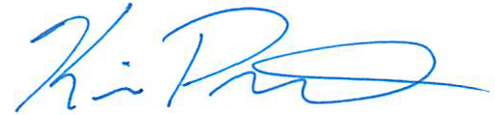

Kevin Pawlos

Director, Office of Management & Budget

Attachments

**526 CITY-COUNTY BUILDING 414 GRANT STREET PITTSBURGH, PENNSYLVANIA 15219**

[www.pittsburghpa.gov](http://www.pittsburghpa.gov/)