July 14, 2021

Honorable President and Members
City Council
City of Pittsburgh
510 City County Building
Pittsburgh, Pennsylvania 15219

Re: Field Dedication at Fineview Park (Field): Kenneth W. “Kenny” Minton Sr. Memorial Ballfield

Dear President and Members:

Enclosed for Council’s legislative consideration is a recommendation to accept the naming application to rename the ballpark at Fineview Park (Field) the Kenneth W. “Kenny” Minton Sr. Memorial Ballfield.

This recommendation is a result of Naming Commission hearing on July 12, 2021. A copy of the application is enclosed as well as the minutes of the Naming Commission hearing. As per Chapter 173.02 of the Code of Ordinances, City Council shall hold a public hearing on the recommendation within 60 days of the Naming Commission's action on the application, unless the applicant has agreed in writing or on the record to an extension of time. For your convenience, 60 days from July 12, 2021 is September 10, 2021.

We are requesting a Waiver of Rule 8 to ensure the public hearing occurs within this timeline, as the applicant is hoping to formalize the name change in time for their annual picnic

Upon conclusion of the required City Council public hearing, the renaming of these public facilities shall be approved unless City Council wishes to override the recommendation of the Naming Commission. In this case, a supermajority of a quorum of members is required. The recommendation shall also be approved if City Council fails to take action within sixty (60) days of receiving the Commission's recommendation.

Sincerely,
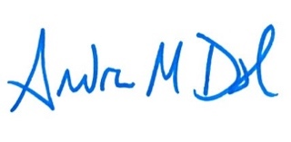
Andrew Dash, AICP
Planning Director
City of Pittsburgh, Department of City Planning

