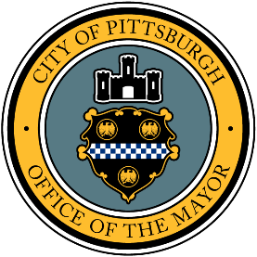

CITY OF PITTSBURGH
OFFICE OF THE MAYOR
MAYOR WILLIAM PEDUTO
December 10, 2021

President and Members of City Council
City of Pittsburgh

Dear President and Members:

Attached is a proposed Resolution authorizing the Mayor and the Director of Finance (on behalf of the City of Pittsburgh) to acquire from the Urban Redevelopment Authority of Pittsburgh (URA) all of the URA’s rights, title and interest, if any, to the URA-owned properties located at 6111 Butler Street in the 10th Ward of Pittsburgh Council District 7 designated as Block 120-G, Lot 145 in the Deed Registry Office of Allegheny County, Pennsylvania and as known as the “62nd Street Site” or the sum of $1.00 plus all necessary and incidental expenses in connection with such acquisition.

Your favorable consideration of this proposed resolution is hereby requested.

Sincerely,

William Peduto

Mayor, City of Pittsburgh

