August 26, 2021

Dear President and Members of Council:

I am submitting a resolution authorizing the Mayor and the Director of the Office of Management and Budget to enter into an Agreement with the Pittsburgh Parking Authority for the completion of the Kirkwood Avenue lot project, as approved in the City of Pittsburgh’s American Rescue Plan.

Should you have any questions regarding the resolution or the agreement, please do not hesitate to contact my office. Your favorable consideration is appreciated.

Sincerely,
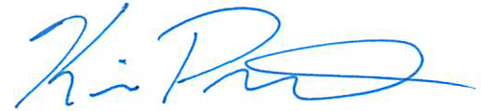

Kevin Pawlos
Director

