June 11, 2021

The Honorable President and Members of City Council
5th Floor, City County Building
414 Grant Street
Pittsburgh, PA 15219

RE: Pennsylvania Museum and Historical Commission Grant Award

Dear Members of Council:

Attached is a proposed Resolution authorizing the Mayor and the Department of City Planning to execute relevant agreements to receive grant funding from the Pennsylvania Historical and Museum Commission’s Keystone Historic Preservation Planning Grant program. The grant will fund a consultant to update the current historical context for the Manchester Historic District to properly reflect events which occurred that supported the Civil Rights Movement. The resolution provides for an agreement and expenditures not to exceed SEVENTEEN THOUSAND FIVE HUNDRED ($17,500.00) dollars for this stated purpose. The grant requires a match from the City of Pittsburgh in the amount of SEVENTEEN THOUSAND FIVE HUNDRED ($17,500.00) dollars for this stated purpose for a total project cost of THIRTY FIVE THOUSAND ($35,000.00) dollars.

Your favorable consideration of the attached proposed Resolution is hereby requested.

Sincerely,

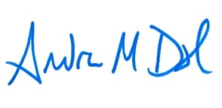

Andrew Dash
Planning Director

