PROJECT NARRATIVE
NEW GRANADA LOBBY INTERIOR RENOVATION
CITY OF PITTSBURGH, ALLEGHENY COUNTY, PENNSYLVANIA

On behalf of the property owner, Hill Community Development Corporation, Cosmos Technologies, Inc. (Cosmos) presents this Project Narrative for the NEW GRANADA LOBBY INTERIOR RENOVATION project. The site is located at 2007 Centre Avenue in the City of Pittsburgh, Allegheny County, Pennsylvania. Erin Street bounds the location to the east, Devilliers Street to the west, Wylie Avenue to the north, and Centre Avenue to the south. The boundaries of the project site are shown on the Site Plan. This 3-Story building was initially a theater.

The location is a 0.34-acre site is within the Allegheny County Parcel 10-N-260/10-N-261. Currently, this parcel is not occupied. The proposed building renovations will include interior renovations and exterior façade improvements. The project scope is to develop a section of the first floor that is street level to Centre Avenue, which will consist of 2 retail spaces and a restroom. The total renovated space will be 1200 square feet.

The client decided to size the Tap-ins to accommodate the full use of the Granada facility. The client had received, for the Interior Lobby Renovation, a PWSA recommendation and DEP approvement for exemption/waiver from the current DEP Sewage Facilities Planning Module regulations. However, the change in the water and sewer tap-ins mandated the need for a new permit application review by PWSA.

The Occupancy count method and the Final Fixture method were used to determine the water consumption of the Granada facility at full use.
The proposed condition based on the following amount of occupancy count is:
First Floor: 286 occupants
Mezzanine: 89 occupants
Second Floor: 618 occupants
Balcony: 385 occupants
Third Floor: 247 occupants

The proposed condition based on the following amount of feature count is:
First Floor: 04 Water Closet
02 Urinal
06 Lavatories
06 Kitchen Sink
02 Drinking Fountain
01 Service Sink
Mezzanine: 13 Water Closet
04 Urinal
16 Lavatories
01 Shower
02 Drinking Fountain
01 Service Sink
Second Floor: 09 Water Closet
03 Urinal
10 Lavatories
05 Kitchen Sink
02 Drinking Fountain
01 Service Sink
Balcony: 04 Water Closet
05 Lavatories
02 Shower
02 Drinking Fountain
Third Floor: 04 Water Closet
02 Urinal
06 Lavatories
01 Kitchen Sink
02 Drinking Fountain
01 Service Sink

Using the flow estimates in Table 2-1 in the PWSA developer manual, the average water consumption would be 14,972 gpd. The number of EDUs in this development project is 38.
We performed the flow calculation for the most hydraulically restricted segment to compute the Total Sewage Flows to Facilities table in Section J of Component 3 for the Sewage Facilities Planning Module. PWSA provided the Hydraulically Limited Sewer Calculation Spreadsheet provided on July 11, 2019, and indicated the hydraulically restricted segment on August 1, 2019. We obtained upstream Invert, downstream Invert, length, and slope of the pipe from the Hydraulically Limited Sewer Calculation Spreadsheet provided on July 11, 2019. However, the contractor (eholdings) measured the flow depth on September 6, 2019, at 7:54 a.m. (please, see the attached letter from eholdings). Due to the time of measurement and following PWSA indications, the measured flow depth corresponds to the present peak flow. We follow “METHOD 1 – Measured PEAK Flow (preferred method)” in the “PWSA SFPM Instructions” that PWSA provides us on July 11, 2019, to complete the calculations attached as 11_Section J_Flow Calculations.pdf file.
Attached is a map that shows the pathway from the site to the treatment plant, which is roughly 7.25 miles away. The pathway goes through pipes in 6 communities, including Bluff, Central Business District, Chateau, North Shore, Marshall-Shadeland, and Crawford-Roberts before it reaches the ALCOSAN treatment plant.

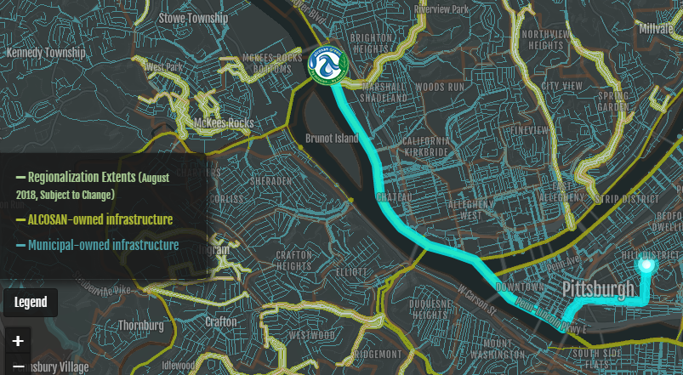
Figure 1. General Map: Path of the sewage to the treatment facility

