December 1, 2020

President and Members of Council
City-County Building
414 Grant Street
Pittsburgh, PA 15219

Dear President and Members of Council:
Enclosed is a resolution authorizing the Mayor and the Department of City Planning to enter into agreements and contracts from the 2020 Professional & Technical Services line as approved by City Council in the City’s 2020 Operating Budget for a Housing Needs Assessment with HR&A Advisors. The Housing Needs Assessment is both an update to the 2015 Housing Needs Assessment and a COVID19 impact analysis, which can and will identify and examine current and future housing needs essential as the City embarks on its first-ever citywide plan, ForgingPGH, and provide for the payment at a cost thereof, not to exceed One Hundred Thousand Dollars and Zero Cent ($100,000.00).
If you have any questions please contact me.

Sincerely,
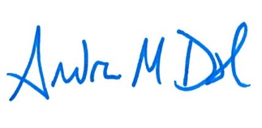
Andrew Dash, AICP
Planning Director
City of Pittsburgh, Department of City Planning

CD/cc

CC: Mayor’s Budget Office
Dan Gilman, Chief of Staff

