CITY OF PITTSBURGH
Office of Management and Budget
William Peduto, Mayor Kevin Pawlos, Director

December 17, 2021

The Honorable President and Members of Council
5th Floor, City-County Building
414 Grant Street
Pittsburgh, PA 15219

Dear President and Members of Council:

Attached is a resolution further amending Resolution No. 797, effective December 28, 2017, as amended, entitled “Resolution adopting and approving the 2018 Capital Budget and the 2018 Community Development Block Grant Program, and the 2018 through 2023 Capital Improvement Program” by reducing ST. AMBROSE MANOR by $6,000, reducing DISTRICT 1 DPW PROJECTS by $12,270, increasing COMMUNITY ALLIANCE OF SPRING GARDEN/EAST DEUSTCHTOWN by $18,270, and authorizing a subsequent Agreement or Agreements.

Waiver of Rule 8 is being requested in order to expedite funds to the community organization.

Your favorable consideration of the Resolution is requested.

Sincerely,
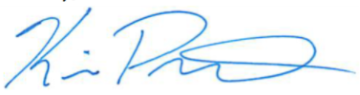

Kevin Pawlos
Director, Office of Management & Budget

Attachments

526 CITY-COUNTY BUILDING 414 GRANT STREET PITTSBURGH, PENNSYLVANIA 15219
www.pittsburghpa.gov

