The City of Pittsburgh
Department of Mobility & Infrastructure

DIRECTOR MEMO

TO: Kim Lucas, Acting Director, DOMI

FROM: Jennifer Massacci, Katie K. Reed, DOMI

CC: Angie Martinez, Assistant Director
Katie Reed, Development Review Planner

RE: Regis Way and portion of Rapidan Way

DATE: August 10, 2022

BACKGROUND:

Steel City Squash (SCS), a 501(c)(3) organization that provides after-school educational and athletic opportunities to City of Pittsburgh school children, seeks a street vacation of Regis Way from Shetland Street to Joseph Street and Rapidan Way from the southern terminus of Lot 147 to its intersection with Regis Way. The reasons behind this request include:

- The siting of the new building requires realignment or vacation of Regis Way, since the footprint must push into the existing cartway.
- Given the restraints of the site, Steel City Squash needs the space along the realigned area for their perpendicular parking spots.
- Realignment would result in Regis remaining as ROW, which SCS worries will not be properly cleared of ice and snow, because a tertiary road like this is not a priority for City services.

Steel City Squash will draft and submit text for a public access easement along the realigned former Regis Way between Shetland and Joseph Streets and small portion of Rapidan Way, which will allow continued full access for the properties along Rapidan Way and for anyone traversing the block.

Steel City Squash has participated in several meetings regarding this street vacation request with Councilman Burgess, the Larimer Consensus Group and East Liberty Development, Inc., including a meeting on April 21, 2021. Councilman Burgess, the Larimer Consensus Group and East Liberty Development, Inc. have all approved Steel City Squash’s street vacation request as well as the easement providing public access from the northern terminus of Rapidan Way to both Shetland and Joseph Streets.

Staff Recommendation:

Staff considered realignment of Regis Way, with continued City ownership, which seemed initially like the preferred treatment, but SCS is concerned about the maintenance of Regis Way. Snow removal will be important for this area, and SCS worries that City maintenance and clearing may not be up to their standards, given that this is not a primary route for the City. Maintaining this area themselves is a preferred method.

Steel City Squash has agreed to provide a public easement and long the realigned former Regis Way between Shetland and Joseph Streets and small portion of Rapidan Way, which will allow continued full access for the properties along Rapidan Way.

Staff recommendation is to submit the vacation of Regis Way between Joseph and Shetland Streets, as well as the small portion of Rapidan Way from the southern terminus of Lot 147 to its intersection with Regis Way to City Council for consideration. The City of Pittsburgh and URA are the abutting property owners and have signed off on the street vacation petition. The URA owned lot is in the process of being consolidated with the City owned properties.

Photo 1: Existing google view
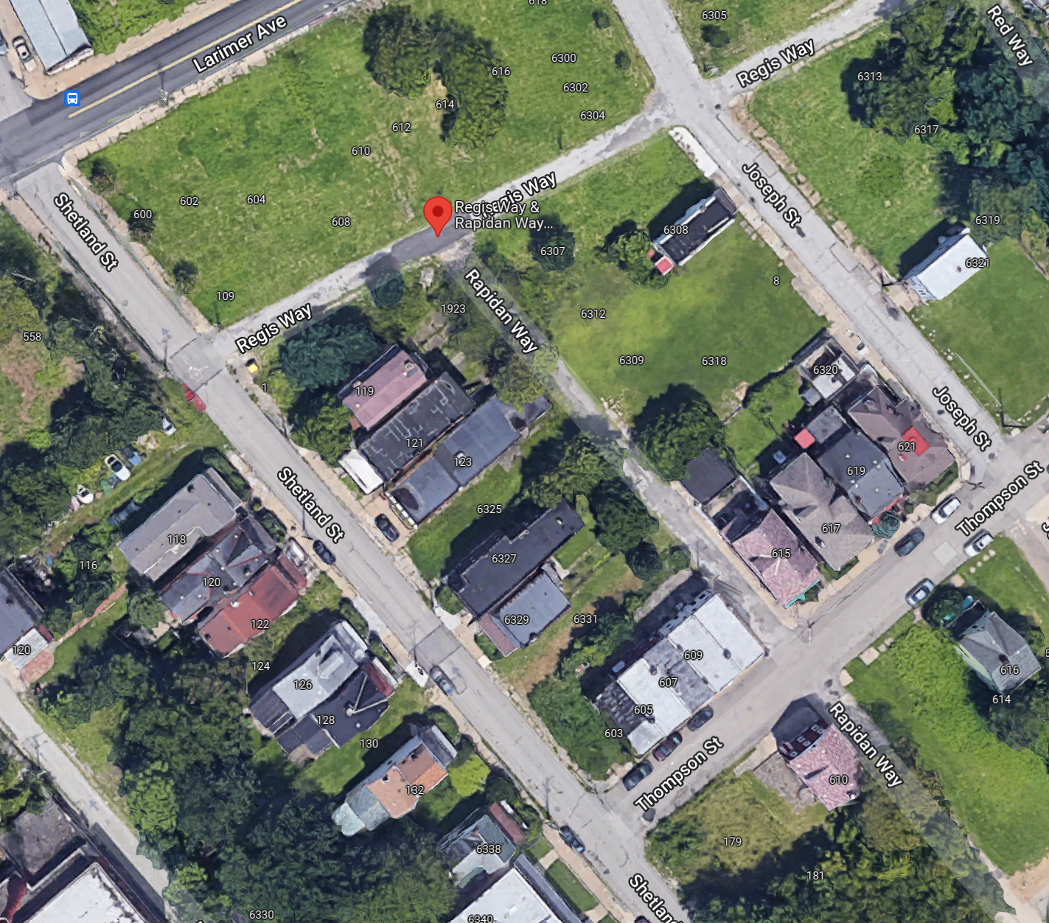

PHOTO 2:
Site Plan overlaid with Regis & Raiden Way ROW. Site plan cannot be accomplished within existing property line.

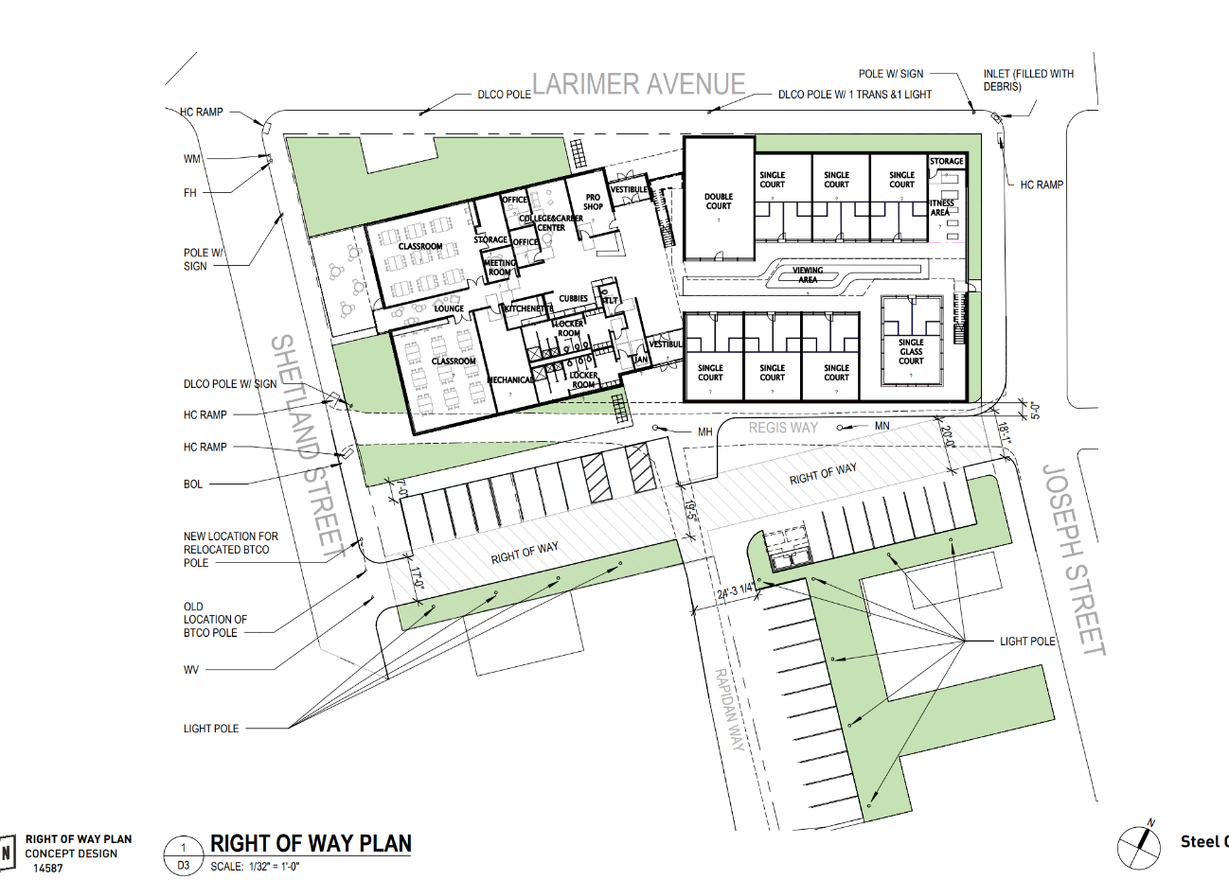

PHOTO 2:
Proposed Regis Way street vacation
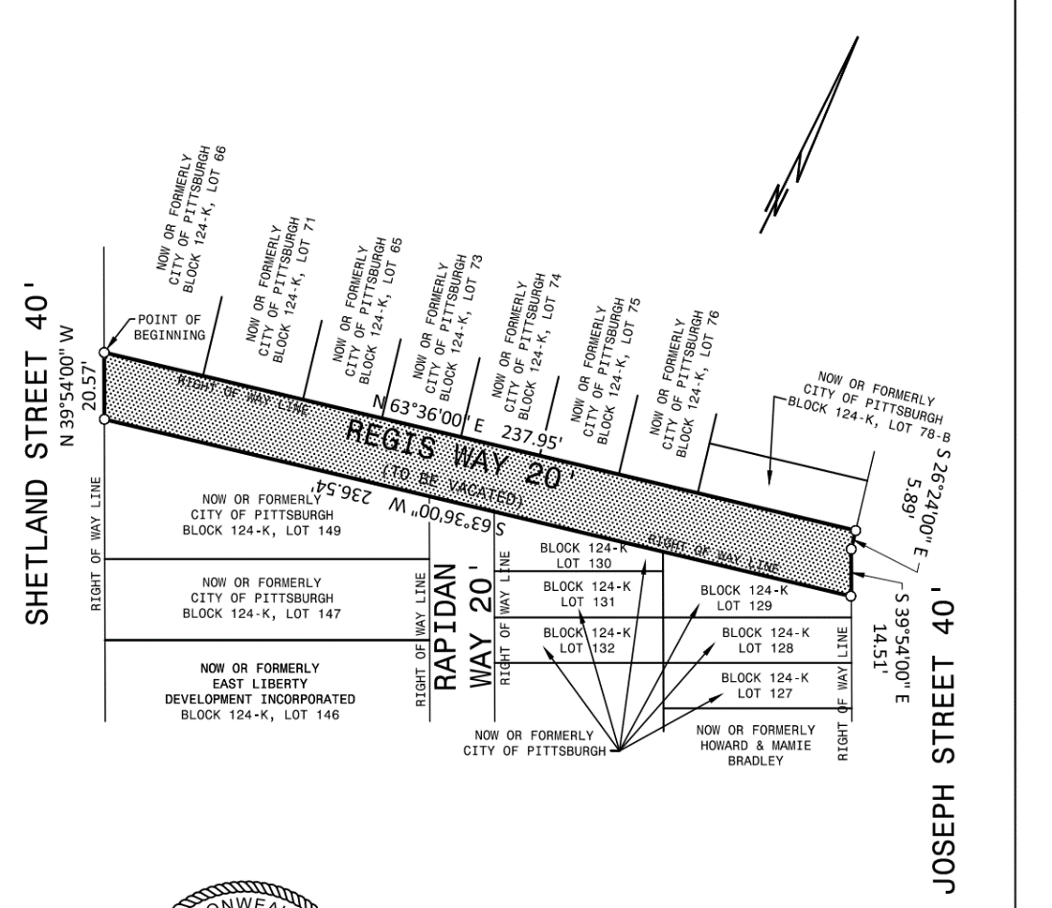

Photo 4: Proposed Rapidan Way street vacation
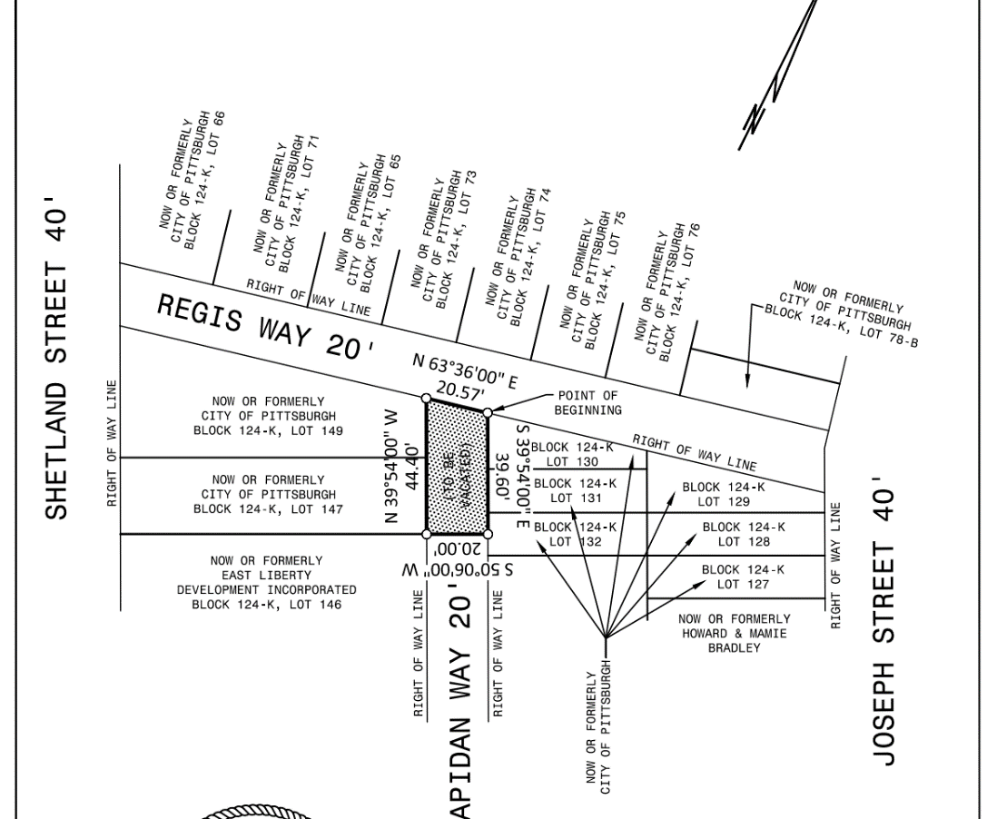

Photo 5: Future Subdivision/Lot Consolidation Plan
Showing vacation of Regis Way and public easement (gray)
