November 30, 2020

President and Members of Council
City-County Building
414 Grant Street
Pittsburgh, PA 15219

Dear President and Members of Council:

Enclosed is a legislation authorizing the Mayor and the Department of City Planning to enter into agreements and contracts from the 2020 Professional & Technical Services line as approved by City Council in the City’s 2020 Operating Budget with Maalka, for the purpose of providing a building benchmarking management platform for the Department of City Planning.
The platform will streamline the tracking of compliance with Pittsburgh Code Chapter 629- BUILDING BENCHMARKING; support outreach to building owners to increase participation, and provide transparency to the public with tools such as visualization map and dashboard. The platform will be provided for a year for the payment at a cost not to exceed $20,000.00.
We request to waive Rule 8 as Covid-19 disrupted coordination effort and the RFP publication.

If you have any questions, please contact me.

Sincerely,

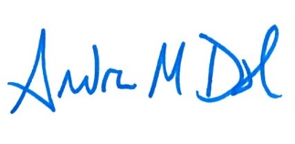
Andrew Dash, AICP
Planning Director
City of Pittsburgh, Department of City Planning

