
CITY OF PITTSBURGH
Office of Management and Budget
William Peduto, Mayor Kevin Pawlos, Director

July 28, 2026

The Honorable President and Members of Council
5th Floor, City-County Building
414 Grant Street
Pittsburgh, PA 15219

Dear President and Members of Council:

Attached is a resolution providing for an agreement with the Urban League of Pittsburgh, for the implementation/administration of the Housing Counseling Program, and related costs, in the amount not to exceed $100,000.00.

Your favorable consideration of the Resolution is requested.

Sincerely,
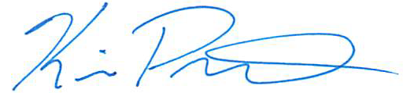

Kevin Pawlos
Director, Office of Management & Budget

Attachments

526 CITY-COUNTY BUILDING 414 GRANT STREET PITTSBURGH, PENNSYLVANIA 15219
www.pittsburghpa.gov

