April 12, 2021

Honorable President and Members
City Council
City of Pittsburgh
510 City County Building
Pittsburgh, Pennsylvania 15219

Re: Renaming of “Niagara Parklet” to “Oakcliffe Community Playground”

Dear President and Members:

Enclosed for Council’s legislative consideration is a recommendation on an application brought before the Naming Commission to deny the renaming application from “Niagara Parklet” to “Oakcliffe Community Playground” on the condition that the Commission would support the renaming to “Oakcliffe Park,” which adheres closer to the City’s current naming conventions.

This recommendation is a result of Naming Commission hearing on January 4, 2021. A copy of the application is enclosed as well as the minutes of the Naming Commission hearing. As per Chapter 173.02 of the Code of Ordinances, City Council shall hold a public hearing on the recommendation within 60 days of the Naming Commission's action on the application, unless the applicant has agreed in writing or on the record to an extension of time. The applicant did agree in writing to an extension of 60 days as of the date of this letter.

Upon conclusion of the required City Council public hearing, the renaming of these public facilities shall be denied by unless City Council wishes to override the recommendation of the Naming Commission. In this case, a supermajority of a quorum of members is required. The recommendation shall also be deemed denied if City Council fails to take action within sixty (60) days of receiving the Commission's recommendation.

Sincerely,
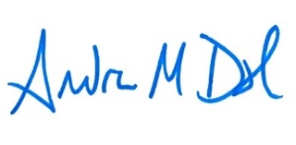
Andrew Dash, AICP
Planning Director
City of Pittsburgh, Department of City Planning

