January 11, 2021

President and Members
City Council
City of Pittsburgh

Dear President and Members:

We submit for your consideration Resolution authorizing the Department of Parks and Recreation to enter into a Community Partner Access Agreement or Agreement(s) with Voices Against Violence for use of the McKinley Community Center in order to provide recreational and community-focused activities. Such Agreement(s) shall be at no cost.

Your favorable consideration of this resolution is hereby requested.

Very truly yours,

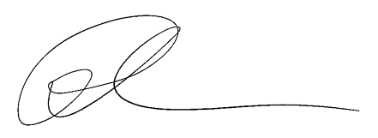
Ross Chapman
Director

RC/LH

Attachment

