January 11, 2021

President and Members
City Council
City of Pittsburgh

Dear President and Members:

We submit for your consideration a Resolution providing for an Agreement or Agreements, Lease(s) and/or License Agreement(s) for the use of certain property for senior facilities for the provision of center services to seniors. The cost of this Agreement or Agreements, Lease(s) and/or License Agreement(s) shall not exceed Fifteen Thousand, and Two Hundred Dollars ($15.200.00), chargeable to and payable from the Seniors Community Trust Fund, Account 5000285000.54501.00, Year 2021 in the Department of Parks and Recreation.

Your favorable consideration of this resolution is hereby requested.

Very truly yours,

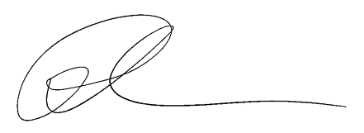
Ross Chapman
Director

RC/LH

Attachment

