January 8, 2021

Honorable President and Members
City Council
City of Pittsburgh
510 City County Building
Pittsburgh, Pennsylvania 15219

Re: IPOD-6, Inclusionary Housing Interim Planning Overlay District

Dear President and Members:

Enclosed for Council’s legislative consideration is a resolution to grant the single six month extension to the Inclusionary Housing Interim Planning Overlay District., IPOD-6 as per the Pittsburgh Code, Title Nine, Section 907.02.C: Time Limit. The original expiry date of the district referenced in Section 907.02.K, known as IPOD-6, Lawrenceville, is January 25, 2021. This resolution shall extend this by six months to July 25, 2021.

This resolution is transmitted as a result of favorable Commission action on December 8, 2020.

A copy of Inclusionary Housing Interim Planning Overlay District map and a copy of the Commission’s report and recommendation is enclosed. The bill may be enacted with 5 affirmative votes.

To maintain the current IPOD-6, the Council needs to take final action by January 25, 2021. Because of this short timeline, I am requesting the waiving of Rule 8 for this legislation.

Yours truly,

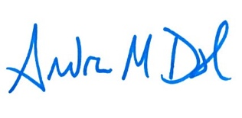
Andrew Dash, AICP
Planning Director

Enclosures

cc: Corey Layman, Zoning Administrator
Dan Gilman, Mayor’s Office
Deborah Gross, City Council
Bobby Wilson, City Council
File

