November 20, 2020

President and Members of City Council
510 City-County Building
414 Grant Street
Pittsburgh, PA 15219

Dear President and Members:

Attached is a proposed Resolution for the designation as a City Historic Structure, The VA Facility Laboratory Building 13, located at 7180 Highland Drive, Lincoln-Lemington-Belmar, in the 12th Ward, City of Pittsburgh.

In accordance with Historic Preservation Ordinance, the Historic Review Commission and the City Planning Commission have reviewed the nomination of The VA Facility Laboratory Building 13 as a Historic Structure. Both the Historic Review Commission and the City Planning Commission voted to recommend that City Council designate The VA Facility Laboratory Building 13 as historic so that it may be protected and preserved.

The Historic Preservation Ordinance calls for Council to hold a public hearing on the nomination within one-hundred and twenty days (120) days of the Planning Commission’s recommendation (February 10, 2021), and then to vote on the designation within one-hundred and twenty (120) days of receipt of these recommendations.

If you have any questions, please contact me or Sarah Quinn, Historic Preservation Planner, at Sarah.Quinn@pittsburghpa.gov.

Sincerely,
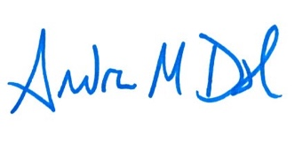

Andrew Dash, AICP
Director of City Planning

Cc: File

