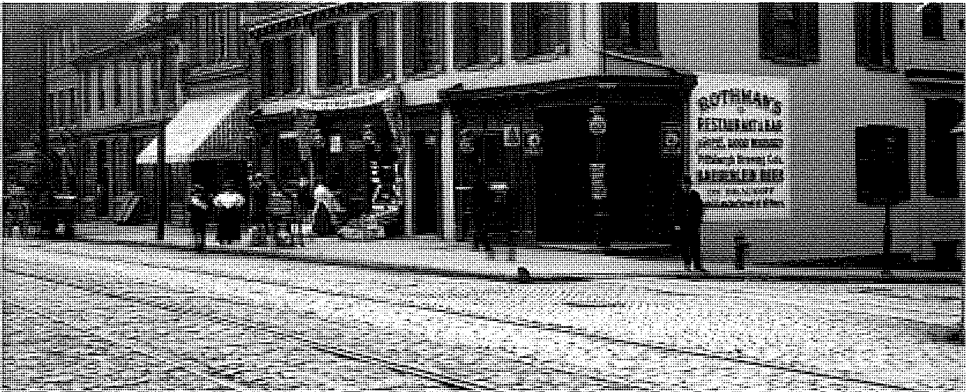

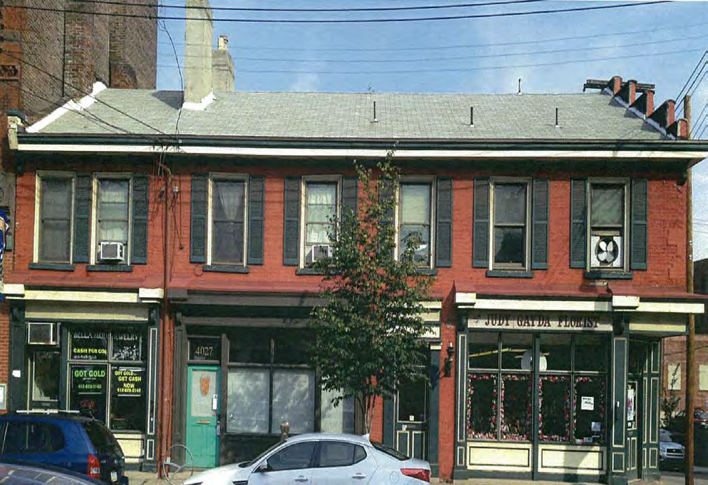

NASER’S TAVERN - HISTORIC NOMINATION STAFF REPORT

Name of Property ................................. Naser’s Tavern
Address of Property ............................. 4025-4029 Butler Street
Property Owner .................................... Lawrenceville Holdings, LP Nominated by: ....................................... Lawrenceville Stakeholders, LLC Date Received:....................................... 20 November 2013
Parcel No.: ............................................. 49-F-9
Ward:..................................................... 9th
Zoning Classification:........................... LNC Neighborhood........................................ Lawrenceville Bldg. Inspector:..................................... Mark Sanders Council District:.................................... 7 - Gross

FORMAL ACTION REQUIRED BY THE HISTORIC REVIEW COMMISSION:
1. Act on the Preliminary Determination of Eligibility for Historic Designation (2 December 2013)
2. Conduct a public hearing for the Historic Designation (2 December 2013 and 8 January 2014)
3. Review the Report prepared by staff for the property in question, and make a recommendation to the
City Council on the Historic Designation (8 January 2014)

FORMAL ACTION REQUIRED BY THE PLANNING COMMISSION:
4. Conduct a public hearing for the Historic Designation (4 March 2014)
5. Review the recommendations of the Historic Review Commission and make a recommendation to the
City Council on the Historic Designation (4 March 2014)

FORMAL ACTION REQUIRED BY THE CITY COUNCIL:
6. Conduct a public hearing for the Historic Designation
7. Review the recommendations of the Historic Review Commission and the City Planning Commission and take action on the Historic Designation

TIMELINE:

Nomination: Naser’s Tavern Occurred

Must Occur
Before

Nomination Submitted | 20-November-13
 | With Check
Date of Notice sent to Property Owner | 21-November-13 | 26-November-13
Date of Notice Sent to each Owner of
Record | N/A | N/A
Date of Preliminary Determination
Hearing | 4-December-13 | 5-January-14
Date of Public Hearing | 8-January-14
Date of HRC's Recommendation | 8-January-14
Date of PC Briefing | 4-February-14
Date of PC's Recommendation | 18-February-14 | 18-February-13
Date Recommendations sent to CC | 14-March-14 | 20-April-14
Date of City Council Hearing
Date of Adoption by City Council |  | 20-September-14
Mayor Signs
Effective Date

FACTS

1. On 20 November 2013, the staff of the Historic Review Commission received an application for the nomination of Naser’s Tavern to be designated as a City Historic Structure.

2. Description of Naser’s Tavern (as extracted from the nomination form)
The building is a two-story brick commercial structure with modest Greek Revival influence, with rear additions dating to the late 19th century. The building has three storerooms and an apartment entrance door at street level.
Its side-gabled roof is clad in asphalt shingles and has a stepped, parapeted side gable facing 41st Street. The main
block of the building has brick chimneys extending from the front and rear roof slopes.

The facade of the main block has first-story storefronts with traditional window openings, door placement, and commercial cornices. The apartment entrance opening, between two of the storefronts, is flanked by Greek Revival flat "columns" that support an entablature. The first story of the building at the corner of 41st Street is cut away, giving that storeroom a corner entrance. The facade's second story window openings are fitted with one- over-one-light double-hung replacement windows and flanked by modern louvered shutters. There are small brackets below the box gutter. The 41st Street side of the main block has no openings on its first floor and three window openings on its second floor.

The ell is of brick construction and rests on an un-coursed stone foundation. It is one story with a partially above ground basement. Its roof is flat, and the roof cladding cannot be determined. The ell is seven bays deep along
41st Street, with segmentally arched window and door openings, which have been partially in-filled and fitted
with early to mid-20th century metal casement windows and an air conditioning unit.

The small wood frame addition is two bays deep along 41st Street and is clad in slate shingles. Its window openings are fitted with double-hung replacement windows. The cladding of its flat roof cannot be seen.

The rear section of the building is attached to the ell, and measures the width of the lot, parallel with Butler Street and Eden Way. The rear section is of brick construction and rests on a foundation of cut sandstone. Its roof is flat, and its roof cladding cannot be seen. The rear section measures three bays along 41st Street and four to six bays facing Eden Way.

3. History of Naser’s Tavern (as extracted from the nomination form)

John Kingan purchased the property that included the site of 4025-29 Butler Street from the Bank of the United States on February 6, 1833. John Kingan was a brick manufacturer and bricklayer who worked and lived in Lawrenceville between the 1830s and the 1860s or later. John Naser purchased the property from Kingan in 1846. John Naser was born in Wurtemburg, Germany, in about 1800, and appears to have come to the United States in 1835. Pittsburgh directories published in and after 1850 listed Naser as operating an inn or tavern in the building at 4025-29 Butler Street; Naser lived on the premises with his family. He called the inn Our House. He also operated an early horse-car line, possibly the first, between Lawrenceville and Downtown, in the 1840s and until 1853. He owned 4025-29 Butler Street until 1878, when he conveyed it to his son Charles P. Naser.

The Allegheny Arsenal occupied Butler Street between 39th and 40th streets, and scattered grocers, bakers, butchers, boot and shoemakers, and hotels extended about a block further in both directions. Various artisans such as blacksmiths, saddlers, and tinners also lived on Butler Street, although the number of them who were self-employed on their own properties rather than at the Arsenal is unclear. Many Arsenal workers lived on 38th through 41st streets, and supported the small Butler Street businesses.

Butler Street inns such as Naser's, and to some extent the other businesses, also profited from Butler Street's importance as a regional transportation route in the pre railroad era. Farmers who brought produce and livestock to Lawrenceville or Pittsburgh and other travelers stayed at small inns such as Naser's, which were an integral component of local commerce. Other communities that have since been absorbed into

Pittsburgh, including Birmingham on the South Side and Deutschtown on the North Side, had their own inns that farmers and other travelers patronized. John Naser strengthened the transportation connection between Lawrenceville and Pittsburgh with his horse-car service. Naser's inn and its peers in other neighborhoods also served as lively, if occasionally disreputable, community focal points Uohn Naser himself reportedly killed a bar patron in a fight in 1852).

Charles P. Naser took over the proprietorship of his father's inn and tavern at 41st and Butler streets in the mid-1870s, before he purchased the property. He ran the business until about 1905, expanding the building in stages. After 1905, Naser and other family members rented the building to tenants. Samuel and Theodore Rothman operated the tavern beginning in 1906, and lived upstairs with other family members. The Rothmans ran the business for several years. Members of the Naser family owned 4025-29 Butler Street until 1943, when they conveyed the property to Ida and Herbert Bertenthal. Title passed to Anne E. and S. Mark Bertenthal in 1996 and to Lawrenceville Holdings Ill LP in 2009.

4. Significance of Naser’s Tavern

The Pittsburgh Code of Ordinances, Title 11, Historic Preservation, Chapter 1: Historic Structures, Districts, Sites and Objects lists ten criteria, at least one of which must be met for Historic Designation. The Historic Review Commission is of the opinion that Naser’s Tavern meets several of the criteria as follows.

(a) Criterion 3 - Exemplification of an architectural type, style, or design distinguished by innovation, rarity, uniqueness, or overall quality of design, detail, materials, or craftsmanship.

(b) Criterion 8 – Exemplification of a significant pattern of neighborhood development or settlement.

(c) Criterion 10 – Its unique location and distinctive physical appearance or presence representing an established and familiar visual feature of a neighborhood, community, or the City of Pittsburgh.

In addition, the Commissioners felt that the integrity requirements under Section 1101.04 were met.

5. Maps

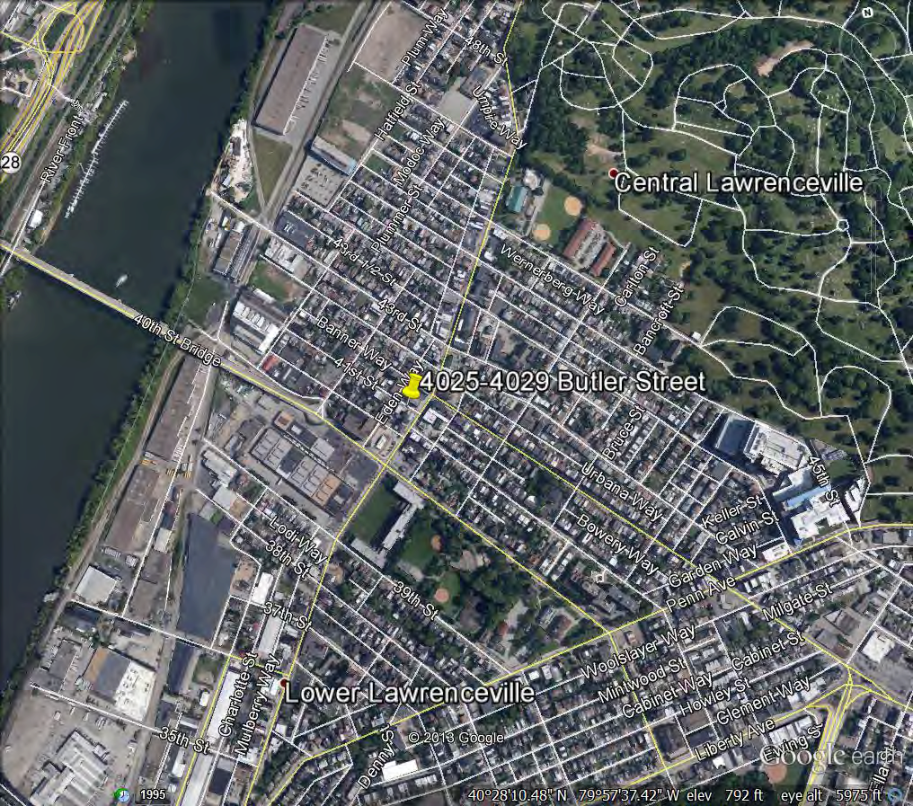

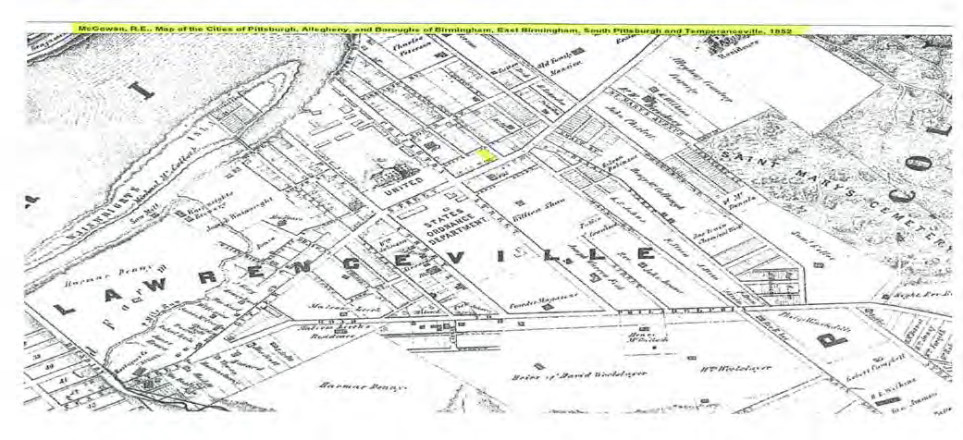

6. Recommendation of the Historic Review Commission

The Historic Review Commission held public hearings regarding the designation of Naser’s Tavern on January 8 and February 5, 2014. On February 5, 2014 the Commission voted to recommend to City Council that it designate Naser’s Tavern as a City Historic Structure.

7. Recommendation of the City Planning Commission

The City Planning Commission held a public hearing regarding the designation Naser’s Tavern on March 4,
2014. On March 4, 2014 the Commission voted to recommend to City Council that it designate Naser’s
Tavern as a City Historic Structure.

8. Meeting Minutes

HRC MINUTES – DECEMBER 4, 2013 – PRELIMINARY DETERMINATION HEARING

4025-4029 Butler Street
Pittsburgh HRC – December 4, 2013

Naser’s Tavern Nomination for Historic Designation

Owner:
Lawrenceville Holdings III LP
4023 Butler Street
Pittsburgh, Pa 15201

Nominator:
Lawrenceville Stakeholders Inc. PO Box 40151
Pittsburgh, Pa 15201
Ward: 9th

Lot and Block: 49-F-9

Inspector: Mark Sanders

Council District: 7th

Application Received: 11/20/13

National Register Status: Listed: Eligible:

Proposed Changes: Nomination for historic designation.

Discussion:

1. Ms. Quinn makes a short presentation about the building, describing its architecture and history. She states that the criteria for historic designation that she found the building meets are not necessarily the same as in the nomination. The first criterion is #3, as it was influenced by the Greek Revival style and was constructed to the smaller scale that was common in pre-Civil War business districts. The second criterion it meets is #7, as the hotel and tavern supported the development of the neighborhood and also supported commerce and transportation in the neighborhood and city. The next criterion it meets is #8, as the building was in the original plan of the town of Lawrenceville, which grew up around the Allegheny Arsenal. The final criterion it meets is #10, as the building retains its location and historic appearance and has been a significant component of the streetscape for 165 to 180 years. The building has also retained integrity of location and design. It occupies its original site and is still in the heart of the business district. The 20th century façade renovations used similar materials that complement the original design and historic additions. The building is still recognizable as a circa 1840 commercial property. She states that the nomination was well-written, and her recommendation is that the Commission provides a positive determination that the nomination potentially has merit.

2. Mr. Hogan explains that the Commission is trying to determine today if the nomination meets at least one of the criteria for historic designation, so that it can
move forward to a public hearing before the Commission makes its final

recommendation. He says if they make a preliminary determination today, protection of the building starts immediately. He says he would like to understand more about the Naser family and their role in the community, and asks the nominator to step forward.

3. Ms. Carol Peterson steps to the podium; she is a member of the nominating group, Lawrenceville Stakeholders, and is also an architectural historian. She talks about the history of John Naser, the owner, and his family members who owned other properties in the neighborhood. She speaks about the importance of the tavern and hotel to the development of the business district and Arsenal area. She says that the small, squat form of the building is also very important, especially in contrast to the later, larger buildings around it; these buildings are generally the oldest in the city and deserve protection.

4. Mr. Hogan asks the owner of the building to step forward.

5. Mr. Mitch Zemel who is the attorney representing the owner, Mr. John Burgle with Lawrenceville Holdings, and Mr. Chris Lassey who is an architect and former board member of Preservation Pittsburgh, all step to the podium. Mr. Zemel states that they don’t necessarily object to the historic designation, but he is concerned that the owner was only notified by voicemail the night before the nomination was submitted. He also expresses concern that the building is being looked at as one property, which they feel it is not. They don’t have any intentions of altering the front façade, but they were looking at altering the back portions, which they feel should be considered separately.

6. Mr. Hogan says today they are only determining if the nomination has merit, and they should bring all of these concerns to the next meeting.

Motion:

7. Mr. Serrao motions to accept the nomination for historic designation on the grounds of criterion #3.

8. Ms. McClellan seconds.

9. Mr. Hogan agrees, and says that they need to do more research on the significance of the Naser family. He also feels that criterion #8 has relevance, as a lot of this pre-Civil War fabric has been lost throughout the city.

10. Mr. Serrao amends his motion.

11. Ms. McClellan seconds again.

12. Mr. Hogan asks for a vote; all are in favor and motion carries.

HRC MINUTES – JANUARY 8, 2014– RECOMMENDATION

4025-4029 Butler Street
Pittsburgh HRC – January 8, 2014

Naser’s Tavern Nomination for Historic Designation

Owner:
Lawrenceville Holdings III LP
4023 Butler Street
Pittsburgh, Pa 15201

Nominator:
Lawrenceville Stakeholders Inc. PO Box 40151
Pittsburgh, Pa 15201
Ward: 9th

Lot and Block: 49-F-9

Inspector: Mark Sanders

Council District: 7th

Application Received: 11/20/13

National Register Status: Listed: Eligible:

Proposed Changes: Nomination for historic designation.

Discussion:

1. Mr. Hogan states that at the last meeting the Commission took into consideration the submission by the applicant of the proposal and took some limited testimony, and thus made a determination that there was at least one criterion that met the standard as submitted, and they will today take formal testimony on the nomination.

2. Ms. Quinn states that today they will be making a recommendation to City council on the historic status of the building. She makes a short presentation about the building, describing its architecture and history. She outlines the criteria for historic designation that she found that the building meets. The first criterion is
#3, as it was influenced by the Greek Revival style and was constructed to the smaller scale that was common in pre-Civil War business districts. The second criterion it meets is #7, as the hotel and tavern supported the development of the
neighborhood and also supported commerce and transportation in the neighborhood and city. The next criterion it meets is #8, as the building was in the original plan of the town of Lawrenceville, which grew up around the Allegheny Arsenal. The final criterion it meets is #10, as the building retains its location and historic appearance and has been a significant component of the streetscape for
165 to 180 years. The building has also retained integrity of location and design. It
occupies its original site and is still in the heart of the business district. The 20th century façade renovations used similar materials that complement the original design and historic additions. She states that in her opinion, the property is appropriate for historic designation.

3. Mr. Hogan asks if she can talk more about the significance as far as cultural and

social history.

4. Ms. Quinn says the building represents the developing industrial and trade industries of that time.

5. Mr. Serrao states that he feels the building is not especially unique in this criterion.

6. Ms. Quinn says that some criteria are more strongly represented than others.

7. Mr. Hogan asks for testimony from the nominators; the nominators are not present.

8. Mr. Chris Lasky steps to the podium; he is the agent for the owner. He talks a bit more about the history of the building. He states they have been talking with Ms. Quinn about the historic review process, and states that they did not have any intention of altering the corner building, only the rear portions of the building.

9. Mr. Hogan asks if the rear portions of the buildings are attached to the front.

10. Mr. Lasky says they are physically attached but there are no penetrations through the walls.

11. Ms. Quinn states that they did talk about the historic review process and she let them know that they can bring a project to be reviewed, they don’t have to wait until Council makes a decision.

12. Mr. Hogan explains that the positive recommendation last month put the protections of historic review in place, so any project will just have to go through review.

13. Mr. Serrao says that the process doesn’t preclude demolition, they will just have to come before the Commission and make their case.

14. Mr. Lasky states that there are concerns with the structural integrity of one of the additions, and they will speak with Ms. Quinn about how to bring any project before the Commission. He states that the owner’s group are all fans of Lawrenceville and they are not trying to change it; they want to help grow and enhance it. He states that this project is part of a larger project that has been controversial in the neighborhood, but from the very beginning they were looking to keep the building and its character intact.

15. Mr. Hogan asks for public comment.

16. Ms. Rebecca White steps to the podium; she lives in Lawrenceville. She states that she has spent many years working on the business district, and she is very happy that the façade will remain intact.

17. Mr. Hogan asks for public comment; there is none.

18. The Commission discusses the criteria for historic designation.

Motion:

19. Mr. Serrao motions to make a recommendation that the building be nominated for historic designation based on criteria #3, #8, and #10.

20. Mr. Jennings seconds.

21. Mr. Hogan asks for a vote; all are in favor and motion carries.

PLANNING COMMISSION MINUTES – MARCH 4, 2014

March 4, 2014

10. Hearing' & Action: Historic Nomination: 4025-4029 Butler Street, Naser's Tavern

Ms. Quinn read the nomination into the record. Ms. Quinn stated that the nomination met three criteria and that the Historic Review Commission voted to recommend the nomination to City Council.

There were no comments from the public or the commission members so the Chairwoman called for the motion.

MOTION: That the Planning Commission of the City of Pittsburgh he City Council with a positive recommendation that the proposed historic nomination under Section 11 01.04(b)(3).

MOVED BY Ms. Myers; SECONDED BY Mr. Valentine

IN FAVOR: Watson, Reidbord, Thomas, Meyers, Valentine, Costello

OPPOSED: None CARRIED

