March 20, 2023

The Honorable President and Members of City Council
5th Floor, City County Building
414 Grant Street
Pittsburgh, PA 15219

RE: Professional Services Agreement – Keenan Saiz

Dear President and Members of Council:
Attached is a proposed Resolution to enter into a Professional Services Agreement with Keenan Saiz to aid in the research and project management of the City of Pittsburgh’s Equity Audit of public art and memorials, at a cost not to exceed Fifteen Thousand Dollars ($15,000.00). This amount is payable from fund 40119, JDE account 1174300120.50000.00.
On January 11, 2023, the Office of Management and Budget released a Request for Proposals to solicit a qualified professional with a background in research and project management to aid in an audit of the City of Pittsburgh’s collection of public art, monuments, and memorials. A selection committee chose Keenan Saiz as the candidate most qualified for this role.
Your favorable consideration of this proposed Resolution is hereby requested.

Sincerely,
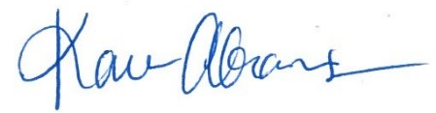
Karen Abrams
Director, City Planning

