October 3, 2022
President and Members of City Council
City of Pittsburgh
RE: Climate Resiliency Fund Grant

Dear Members of Council:
Attached is a proposed resolution authorizing the Mayor and Director of the Department of City Planning to execute relevant agreements to receive grant funding from the Carbon Disclosure Project’s, Climate Resiliency Funds, for development of project plans and funding strategies for resiliency hubs, in the amount of TWENTY-FIVE THOUSAND ($25,000) dollars, and authorizing expenditures for this stated purpose.
Your favorable consideration of the attached proposed Resolution is hereby requested.
Sincerely,
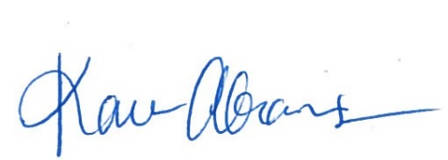
Karen Abrams
Director

