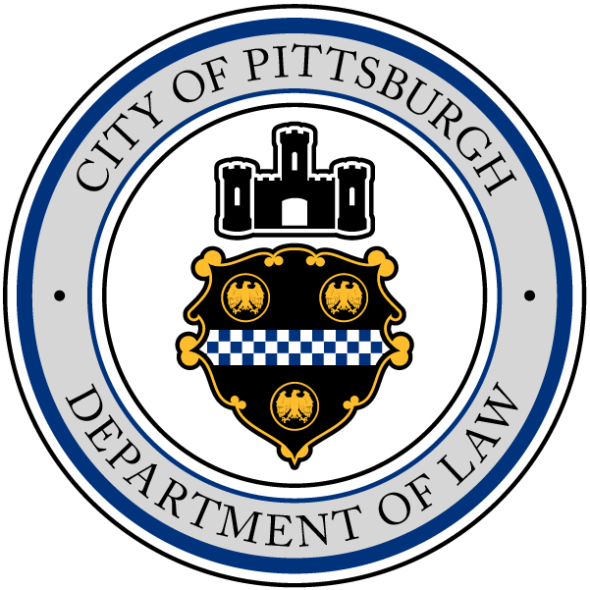
Ed Gainey
MAYOR
Krysia M. Kubiak
CITY SOLICITOR

CITY OF PITTSBURGH
DEPARTMENT OF LAW
CITY-COUNTY BUILDING

To the Committee on Finance
City Council Members
City of Pittsburgh

RE: Property Damage Claim of the Commonwealth of Pennsylvania

This Department has examined a property damage claim presented by The Commonwealth of Pennsylvania, c/o AR PennDOT-Non-APRAS, P.O. Box 15758, Harrisburg, PA, 17105 for damage to an impact attenuator on SR 51 near Woodruff Street from a city police vehicle on May 19, 2021.

PennDOT has provided proof of the total cost of repairs for the impact attenuator in the amount of $11,120.10. Claimant is a self-insured entity. Claimant’s representative has signed the appropriate release for the total repairs to the damaged property in the amount of $11,120.10 and it is of the opinion of Counsel for the City of Pittsburgh that this proposed settlement regarding the property damage be approved.

A Resolution for a warrant in the amount of $11,120.10 is attached hereto for your consideration, chargeable to and payable from Code 11101.108000.58.58105.2022. Item No. 11111-44.

Very truly yours,
Submitted by:
s/Krysia M. Kubiak
s/Margaret A. Vitale
Yvonne S. Hilton
Margaret A. Vitale City Solicitor &
Paralegal & Claims Administrator Chief Legal Officer

