October 1, 2024

President and Members of City Council
510 City-County Building
414 Grant Street
Pittsburgh, PA 15219

RE: Limited-Term Public Art Agreement – 8229 Bricelyn Street – Dornbush Green Infrastructure Project Public Art Installation

Dear President and Members of Council:
Enclosed is a resolution authorizing the Mayor and the Director of the Department of City Planning to enter into an Agreement or Agreements between the City of Pittsburgh and UpstreamPGH for the installation and maintenance of a community-led public art installation located at 8229 Bricelyn Street, at no cost to the City of Pittsburgh.
If you have any questions, please contact me or Kevin Kunak, Assistant Director for Public History, Art, & Design at kevin.kunak@pittsburghpa.gov.

Sincerely,
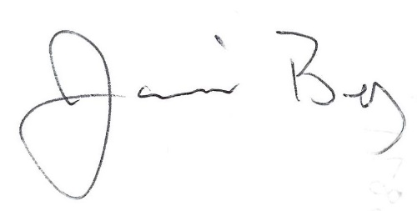
Jamil Bey, Ph.D.
Director of City Planning

cc: file

