

The City of Pittsburgh
Department of Mobility & Infrastructure

DIRECTOR MEMO

TO: Jeff Skalican, Director

FROM: Jen Massacci, Principal Planner

CC: Katie Wettick, Senior RW Manager

RE: DOMI-VAC-2025-13020 – Edlam Way Vacation
DATE: 4/17/2026

APPLICANT:
Amy Hopkins - on behalf of OPEN DOOR PRESBYTERIAN CHURCH

REQUEST TO VACATE:
OPEN DOOR PRESBYTERIAN CHURCH has requested this vacation to consolidate their parcels after the approval of the vacation.

- Width of proposed vacation: 20’
- Length of proposed vacation: approx. 241.88’

REVIEW:
Edlam Way is an unimproved paper street and is currently not used for vehicular traffic. The parcels on both sides of Edlam Way make up the Garfield Community Farm. The 2 parcels owned by the City of Pittsburgh are vacant. All parcels have access from other public streets, Fannell, Cornwall, Wicklow, or Columbo. The vacation of Edlam Way will not impact any landowners’ access. Edlam Way is currently unimproved and blocked to through traffic by gardening supplies and equipment, a covered gardening pavilion, and worktables.

Utility Clearance:
All utilities have signed off on the vacation with no objections. Easements are required.
- PW indicates that there is a 6-inch water main, a 15-inch combined sewer main and two fire hydrants within the proposed street vacation. Pittsburgh Water will require an easement. A copy of the agreement is on file.

Petition: Fully executed petition on file. All abutting property owners have petitioned this vacation.

- City of Pittsburgh relinquished rights to half the paper street– 5-H-269 & 271

Legislation: LEGISLATION.docx

Interdepartment Memos:
Notification was sent for approval on 4/10/26. Approvals/No Objection returned on:
Finance- Received signed petition
Law- No response
DPW- No response
PLI- No response
Zoning- No objection on 6/4
Council office- No objection on 6/2

A Traffic Review was not requested for this unimproved paper street vacation.
Emailed John and Bill to see if we provide services

Notices posted on: 6/5/2026
NOTICE FOR Edlam Way.docx

PHOTO 1: View of the area to be vacated

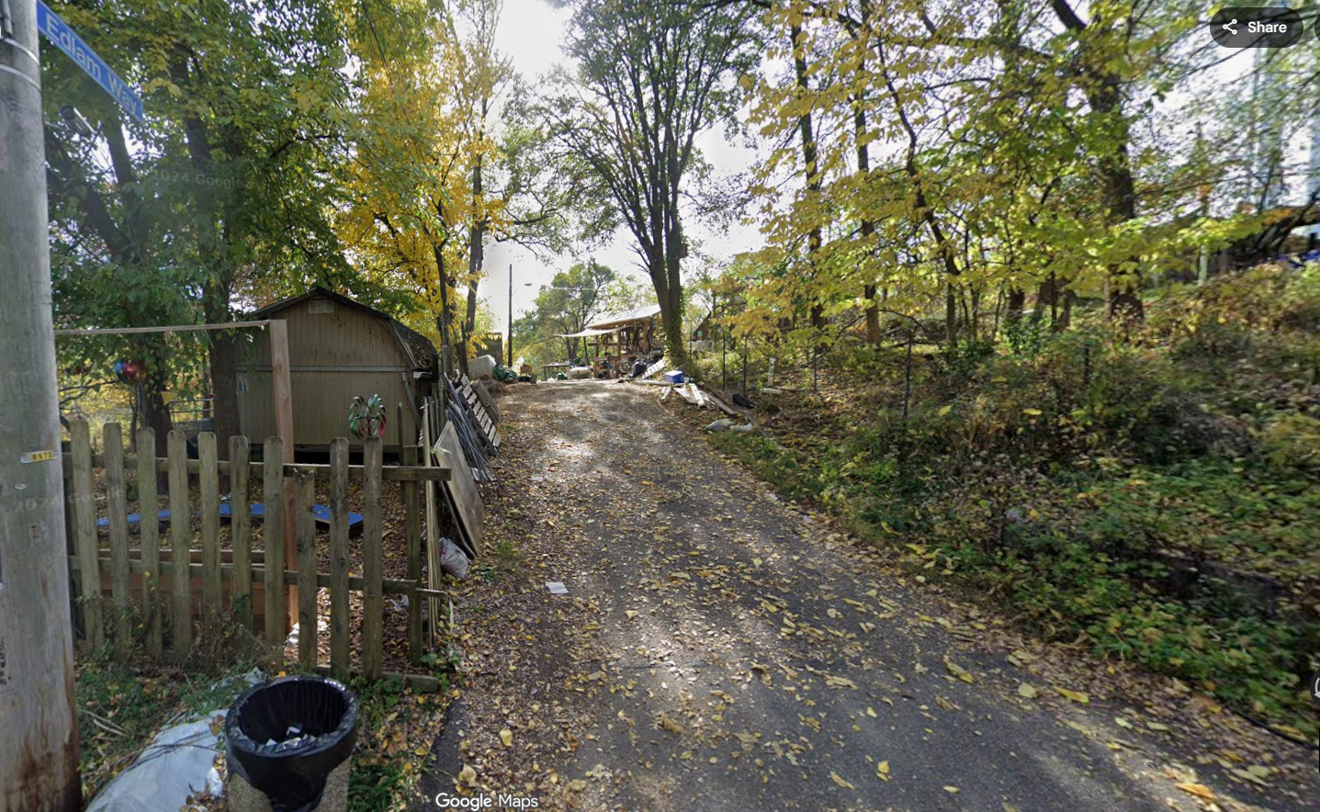

PHOTO 2: Survey - Area to be vacated
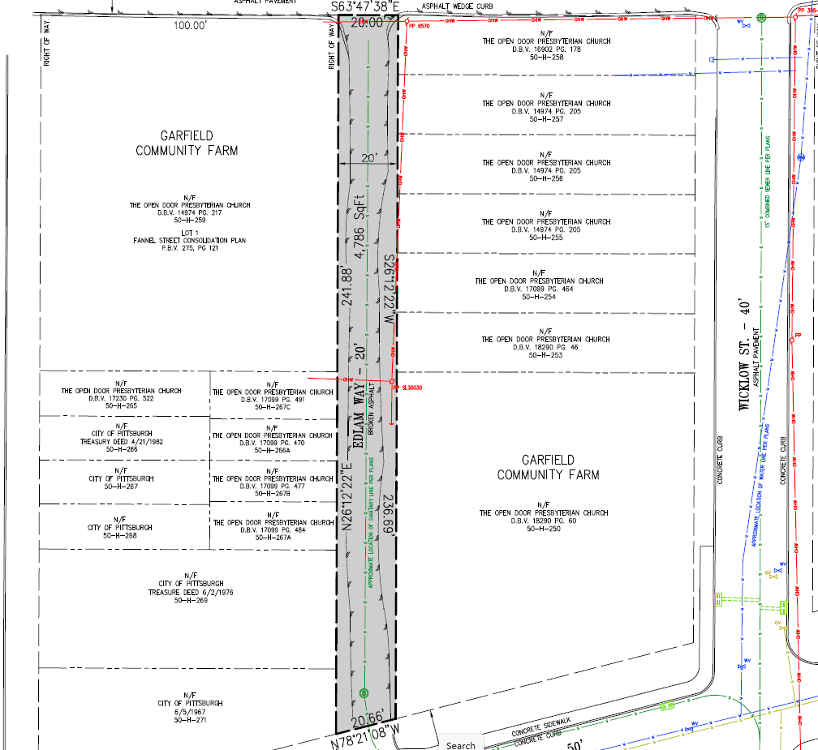

PHOTO 3: Plat book 3 page 6

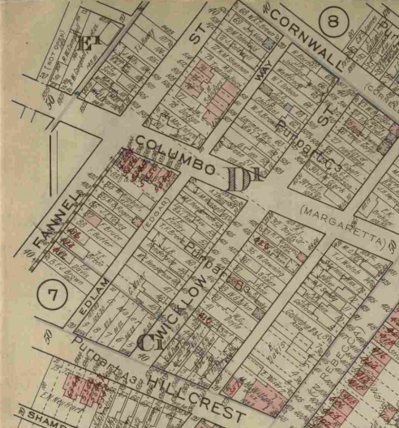

RECOMMENDATION: DOMI Staff recommends approving the application request to vacate this segment of Edlam Way.

