
The City of Pittsburgh
Department of Mobility & Infrastructure

DIRECTOR MEMO
TO: Jeff Skalican, Director
FROM: Jen Massacci, Principal Planner
CC: Katie Wettick, Senior Right-of-Way

RE: Dedication of a portion of a City owned parcel
DOMI-VAC-2026-05882
DATE: 6/3/2026

Reason for Memo:
The City of Pittsburgh is requesting the ROW dedication of a portion of parcel 10-N-357, a City owned parcel where Zone 2 Police Station is situated, to ensure that the driveway entrance to the
police station parking area, and Ebenezer Towers parking area, is able to be improved as part of
the RAISE grant project. The RAISE grant is restricted to improvements in the public ROW and
therefore, to complete the improvements to the Centre/Devilliers/Dinwiddie intersection and the
entrance to the Zone 2 parking area the proposed area must be dedicated to ROW.

Background:
The City of Pittsburgh is undertaking the construction of street infrastructure improvements in the Hill District as part of the New Pathways project, funded by a RAISE grant from USDOT. These improvements include safety improvements that incorporate new sidewalks, steps, traffic signals, and realigned intersections to provide for safer environment for pedestrians, motorists,
and transit riders. Construction is expected to commence starting 2027.

The City of Pittsburgh owns the property where Zone 2 Police Station is situated at the southeast

corner of Devilliers Street and Centre Avenue. When Ebenezer Towers were built in 1980, the former Devilliers Street ROW between Centre Avenue and Rose Street was vacated and a portion was given over to the City as private property attached to the existing Zone 2 property. This driveway remains open and looks like the other surrounding streets however, at the area closest to Centre Avenue, the eastern half of the driveway is City-owned private property while the western half is public ROW.

Review

The resolution that vacated Devilliers Street between Rose Street and Centre Avenue mentions continued shared access by the Police Station and Ebenezer Tower, Devilliers Street was therefore split in half, with one portion attached to the City-owned property to the east (combined into parcel 10-N-357), and the other portion given to the URA who was developing the housing project (separate parcel 10-N-500).

The URA portion of the 1980 street vacation, parcel 10-N-500, was transferred as URA-owned

private property to the City of Pittsburgh ROW through Council action in late-2025. It is

therefore, now public ROW.

The RAISE project proposes to make improvements to the shared driveway accessing Zone 2 and

Ebenezer Towers. The RAISE project proposes to convert the eastern half of the driveway, shown on the plans, to ROW to be consistent with the western half already ROW. This requested dedication therefore maintains the existing use as a shared driveway access to the

Zone 2 and Ebenezer Tower parking area.

Legislation:
Draft of proposed legislation:LEGISLATION.docx

Photo 1: Proposed dedication plan
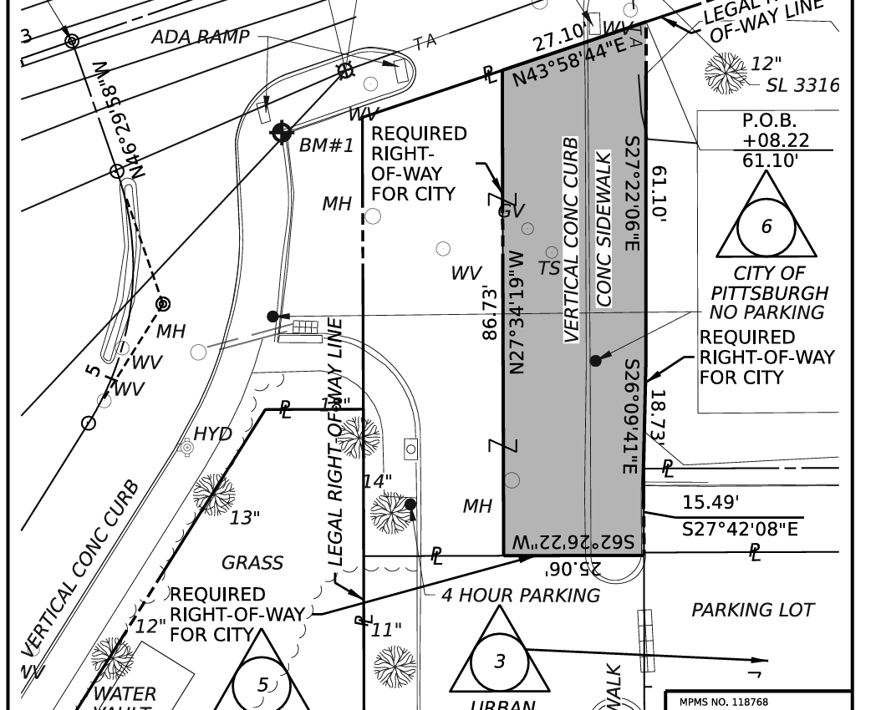

Photo 2: Parcel 10-N-357
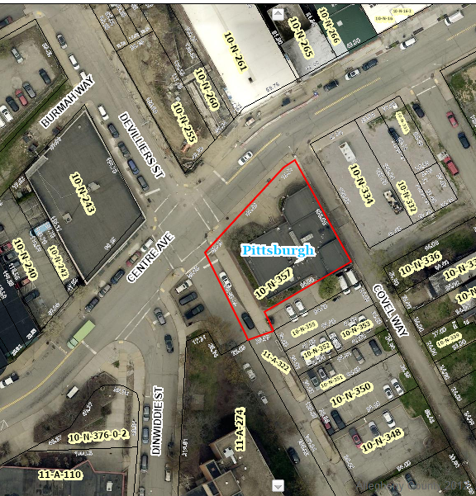

Photo 3: Vacation resolution Vol_114_1980_Book_B_0725.jpg
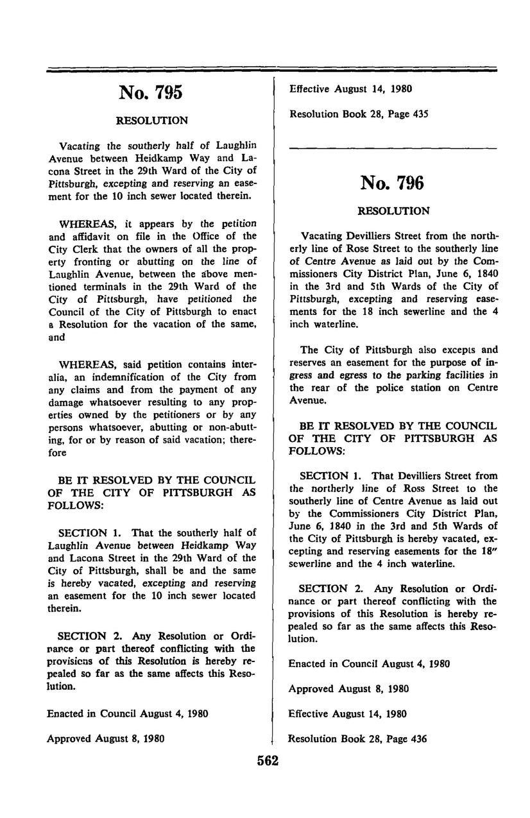

Photo 4: 10-N-500 URA Parcel accepted as Right-of-Way Legislation Text.pdf

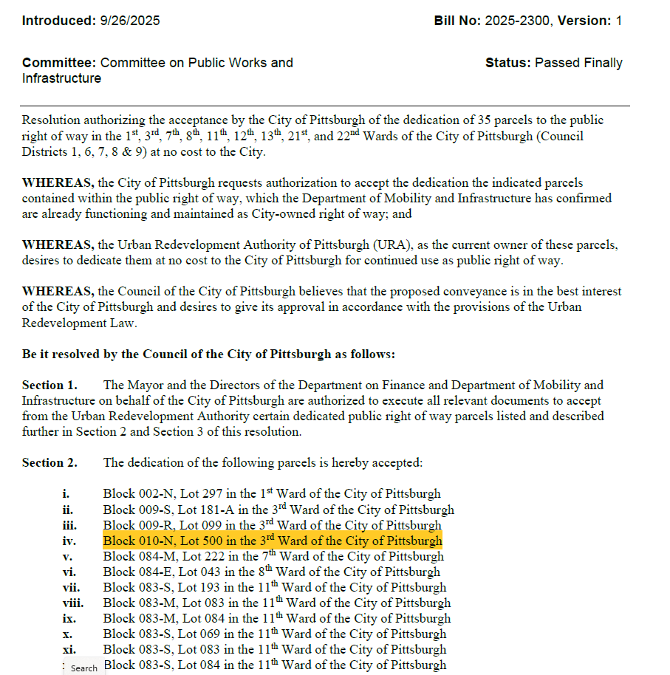

RECOMMENDATION:
DOMI staff fully reviewed the application submitted and recommends accepting the street dedication.

