
The City of Pittsburgh Department of Mobility & Infrastructure

STAFF MEMO

TO: Jeff Skalican, Director

FROM: Jen Massacci, Principal Planner

CC: Katie Wettick, Senior Right-of-Way Manager

RE: DOMI-EN-2025-09594 – 2200 Spring Garden Avenue

DATE: 6/11/2026

APPLICANT: Chris Ehrhardt on behalf of Alcosan
REQUEST TO ENCROACH:
The Allegheny County Sanitary Authority (ALCOSAN) is requesting to build an underground grit chamber to collect sediment in the combined sewer along Spring Garden Avenue (33’ wide right-of-way).

DOMI REVIEW:
The project involves construction of two diversion/connection structures on the existing sewer within the roadway as well as relocation of an existing water line within the Right-of-Way in the 2200 block of Spring Garden Avenue. The proposed encroachments are below grade diversion structures within the roadway that will have no permanent obstruction to the Right of Way.

Traffic control plans will be reviewed by DOMI once excavation permits have been submitted, following the standard permitting process.

Utility Clearance:
All utilities have signed off with no objections.

Legislation: LEGISLATION.docx

Interdepartment/Council Memos: Emailed on 6/11
Notification was sent for approval on 6/12/2026
Approvals/No Objection returned on:
- Finance- No objections on 6/12
- Law’ Response-
- DPW-
- PLI-
- Planning –
- Zoning- BDA-2025-12749 - In review
Traffic Review – Sent to Serge for review on 6/12

PHOTO 1: Areial view of proposed location
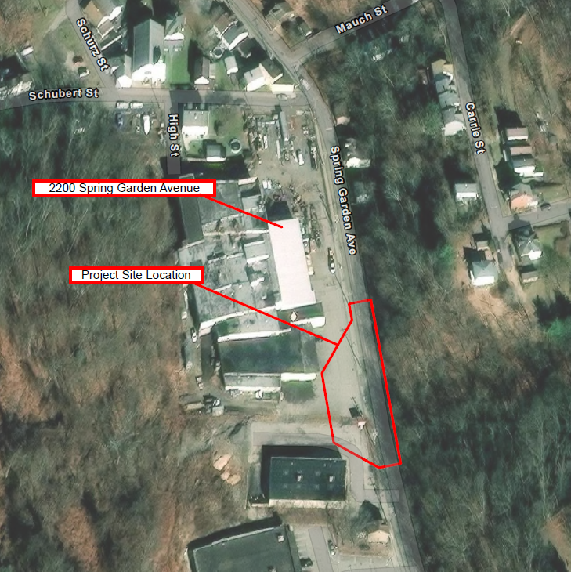

Photo 2: Encroachment plan

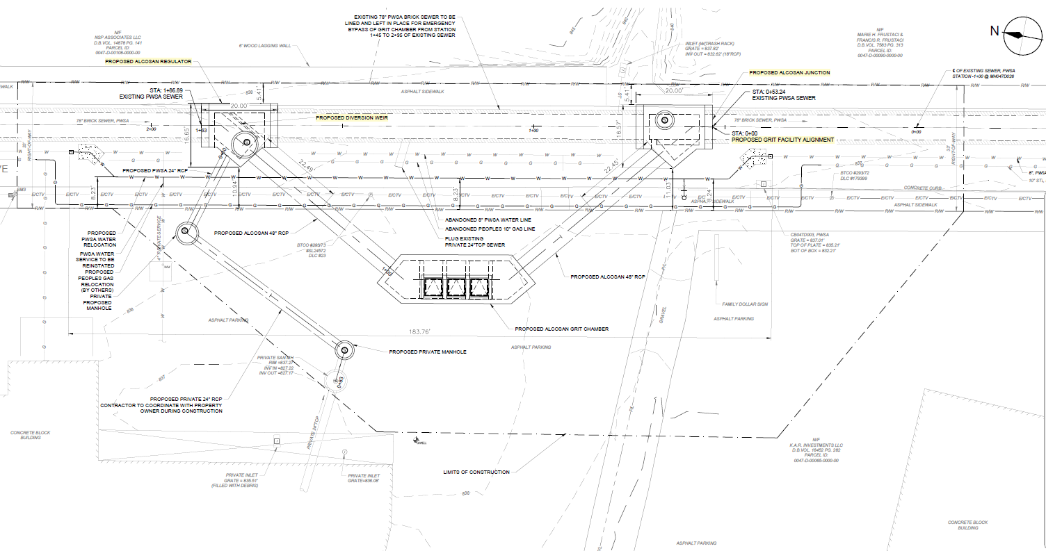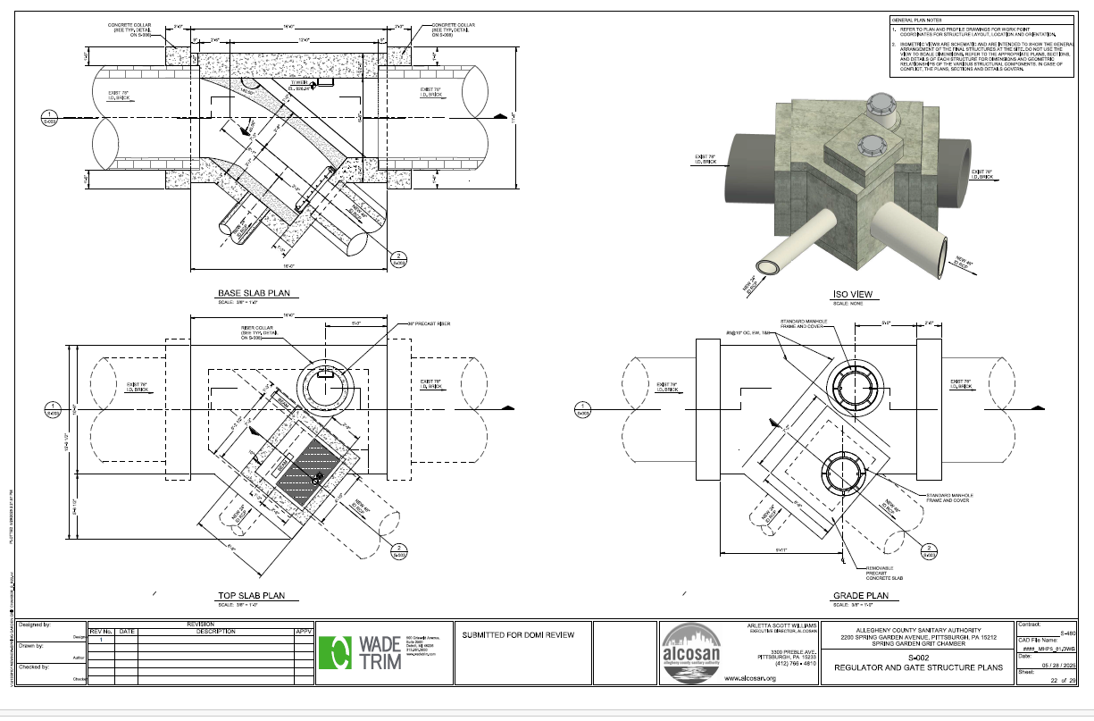
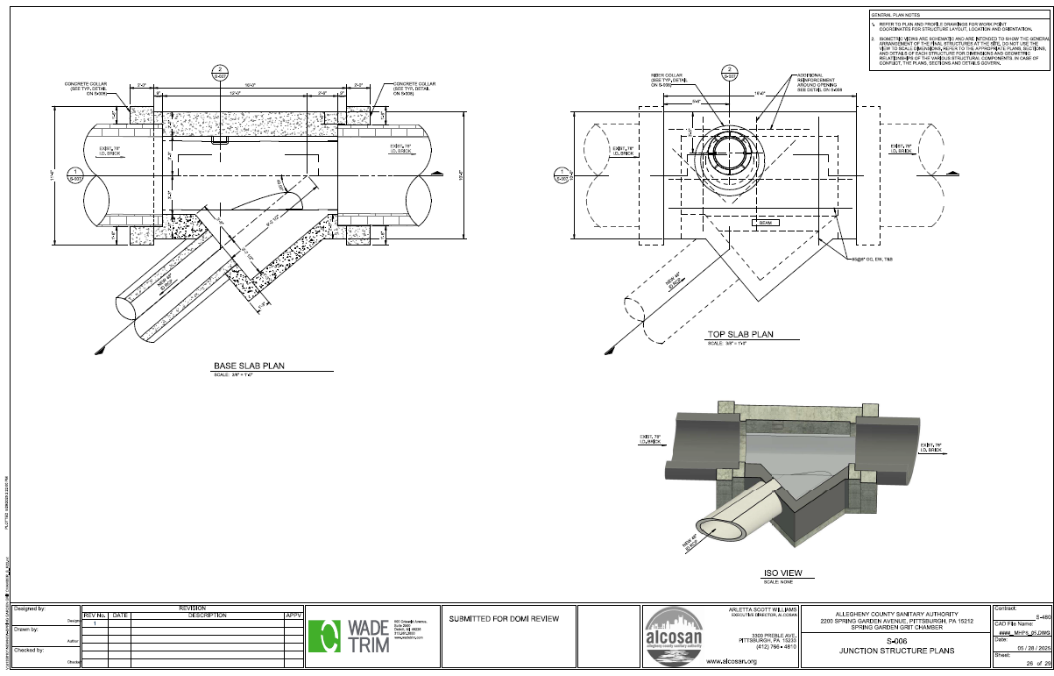

RECOMMENDATION:
DOMI staff’s recommendation is to approve this encroachment application.

