May 22, 2026

Council President Lavelle and Members of Council
Fifth Floor
City County Building
Pittsburgh, PA 15219

Re: 2026 BNY Mellon Sponsorship

Dear President and Members of Council,

The Department of Parks and Recreation will be submitting a resolution authorizing the Mayor and Director of Parks and Recreation to enter Pittsburgh into a financial sponsorship agreement with Bank of New York Mellon Corporation valued at fifty-thousand-dollars for the 2026 City of Pittsburgh Independence Day Celebration. As authorized hereunder, the city will provide opportunities for promotion, recognition and other benefits in exchange for their support.

Should you have any questions regarding the resolution or agreement, please do not hesitate to contact my office. Your favorable consideration is appreciated.

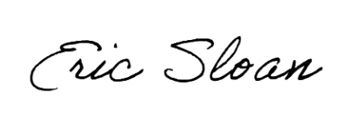
Very truly yours,
Eric Sloan
Director
ES/eb
Attachment

