August 18, 2025

President and Members
City Council
City of Pittsburgh

Dear President and Members:

We submit for your consideration Amending Resolution 32, effective January 29, 2025 for authorizing the Mayor and the Director of the Department of Parks and Recreation, on behalf of the City of Pittsburgh, for the calendar year 2025 to enter into an agreement or agreements, in individual amounts of Ten Thousand Dollars ($10,000.00) or less with various performers, instructors, artists and other persons with specialized skills in connection with the Departments’ various recreational and instructional programs and special events services. The requested amendment is to add text needed for P-Card use to the original Resolution.

Your favorable consideration of this resolution is hereby requested.

Very truly yours,

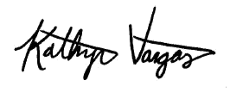

Kathryn Vargas
Director

KV/LH

Attachment

