September 16, 2024
President and Members of Council
City of Pittsburgh
510 City-County Building
Pittsburgh, PA 15219

Dear President and Members,
Resolution amending Resolution No. 629 of 2023 further amending Resolution No. 484 of 2022 further amending Resolution No. 647 of 2021 authorizing the Mayor, the Director of Permits, Licenses, and Inspections, the Director of City Planning and the Chief of Innovation & Performance to enter into an Amended Professional Service Agreement or Agreements with Buildingeye, Inc. ("Buildingeye") to purchase software and related support services that will create an interactive map for internal and public visual display of planning, permit, license, and violation data, by increasing the approved amount by $40,596 for an amended total cost not-to-exceed Six Hundred Twenty Seven Thousand Nine Hundred Thirty Six dollars and Zero Cents ($627,936) over eight and a half (8.5) years.
PLI: $30,447.00 additional encumbrance 11101.130000.53.53509.2024

DCP: $10,149 additional encumbrance 11101.110000.53.53901.2024

This agreement extends the contract for of the Buildingeye, Inc. software tool, allowing city officials, staff, and citizens to search, be notified of, and access information regarding planning, building permit, code enforcement, and business license activities in the City of Pittsburgh.
PLI respectfully requests your favorable approval of this resolution.

Best wishes,
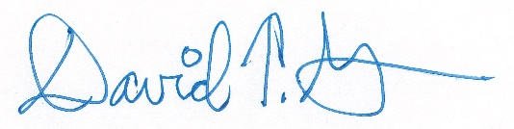
David Green
Director, PLI

