


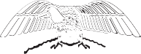







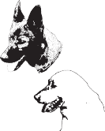




Mike Craig, President Linda Dunn, Vice President

Public Safety Dogs, Inc.
P.O. Box 187
Haw River, NC 27258

https://www.facebook.com/PublicSafetyDogs/

September 2, 2024

Cost breakdown for a trailing dog. There are many things that are miscellaneous that I don’t break down into the individual dogs that are expensive. We have 2 different kinds of insurance that totals about $4200.00 a year and Vehicle repair and maintenance that runs about $3000.00 a year. We drive an average of 1000 miles a week laying trails to age and looking for new places to set up scenario based real life trails for training. Average total cost per dog is $9000.00-10,000.00 depending on number of dogs and if we’re training more than one at a time.

Locating and getting the dog to us $600-$1000.00
Veterinary costs including meds and HW prevention $1600.00
Gas for training $2800.00
Food and supplements $600.00
Kennel supplies $300.00
Working gear $100.00
Bringing in trail layers and helpers and feeding them $300.00

Thank You,


Mike Craig, President Public Safety Dogs, Inc
www.publicsafetydogs.com
336-516-0041

