August 18, 2025

President and Members
City Council
City of Pittsburgh

Dear President and Members:

We submit for your consideration Resolution providing for an Agreement or Agreements with the Pittsburgh Board of Public Education or another vendor chosen through the City bid process for the purpose of providing meals in connection with the 2025-2026 Food Service Program in the Department of Parks and Recreation. The total cost thereof shall not exceed Seven Hundred, Fifty Thousand Dollars and No Cents ($750,000.00), shall be chargeable to, and payable from the following chart of accounts 5000285500.53901.00, 5000285500.53907.00, 5000285500.54101.00, 5000285500.56151.00 in the Department of Parks and Recreation.

Your favorable consideration of this resolution is hereby requested.

Sincerely,
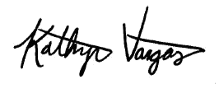

Kathryn Vargas
Director

KV/LH

