April 30, 2026

VIA EMAIL

President and Members of Council
City of Pittsburgh
City Council Chambers
520 City-County Building
Pittsburgh, Pennsylvania 15219-2464

Dear President and Members of Council:

Please find enclosed for your consideration a Resolution amending Resolution #116 of 2024, entitled "Resolution amending Resolution 116 of 2024, authoring the Mayor and the Director of the Commission on Human Relations, on behalf of the City of Pittsburgh, to enter into a Professional Agreement(s) and/or Contract with MBM Law, LLP to provide legal representation as the Solicitor of the Commission on Human Relations and providing for the payment of the costs thereof not to exceed One Hundred Twenty-Five Thousand Dollars ($125,000), for a new not to exceed amount of One Hundred Sixty-Five Thousand Dollars ($165,000).

The Mayor and the Director of the Commission on Human Relations, on behalf of the City of Pittsburgh, are hereby authorized to enter into an amended Professional Service Agreement or Agreements with MBM Law LLP to provide legal representation over two years with the option to renew for three one-year terms at a cost not-to-exceed One Hundred Sixty Five Thousand Dollars ($165,000).”

Sincerely,
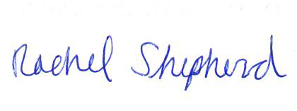
Rachel Shepherd
Director

Enclosures

