
The City of Pittsburgh Department of Mobility & Infrastructure

STAFF MEMO

TO: Jeff Skalican Director

FROM: Jen Massacci, Principal Planner

CC: Katie Wettick, Senior Right-of-Way Manager

RE: DOMI-EN-2025-15359 –217 Halket Street

DATE: 5/17/2026

APPLICANT: Shelley Parekh on behalf of PA-PITT HOLDINGS LLC
REQUEST TO ENCROACH:
PA-PITT HOLDINGS LLC proposes to install permanent shoring and an 8” private water line for new construction.
DOMI REVIEW:
Per zoning requirements, the applicant is required to construct the building to the property line for 65% of its frontage along Halket Street. This project includes a fully below-grade level for parking, which necessitates the use of shoring during the construction process. Due to the nature of the construction site and the placement of the permanent structure, the necessary shoring cannot be placed within the property line. It is imperative for the stability and safety of the excavation and the structure itself that the shoring be erected temporarily within the ROW. There are no existing utilities that would be impacted in the shoring area, and all shoring is intended to be temporary.
The shoring will be placed along Halket Street and Louisa Street to support the construction of a new building. An 8” ductile iron waterline will be installed from Halket St to Halket Place under the Louisa Street sidewalk.

Utility Clearance: All utilities have signed off with no objections.

Legislation: LEGISLATION.docx
Interdepartment Memos:
Notification was sent for approval on 5/17/2026
Approvals/No Objection returned on:
- Finance- No objections on 5/27
- Law’ Response -
- DPW- No objection on 5/28
- PLI-
- Planning –
- Zoning- BDA-2025-11790
- Council – No objection on 5/26
Traffic Review – None
Utility Review - All utilities approved

PHOTO 1: Areial view of proposed encroachment
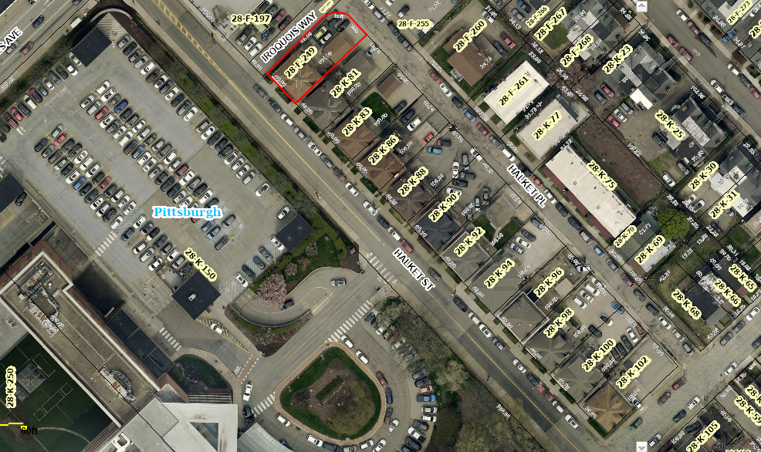

Photo 2: Encroachment shown on plan in blue
EncroachmentDiagramR2.pdf

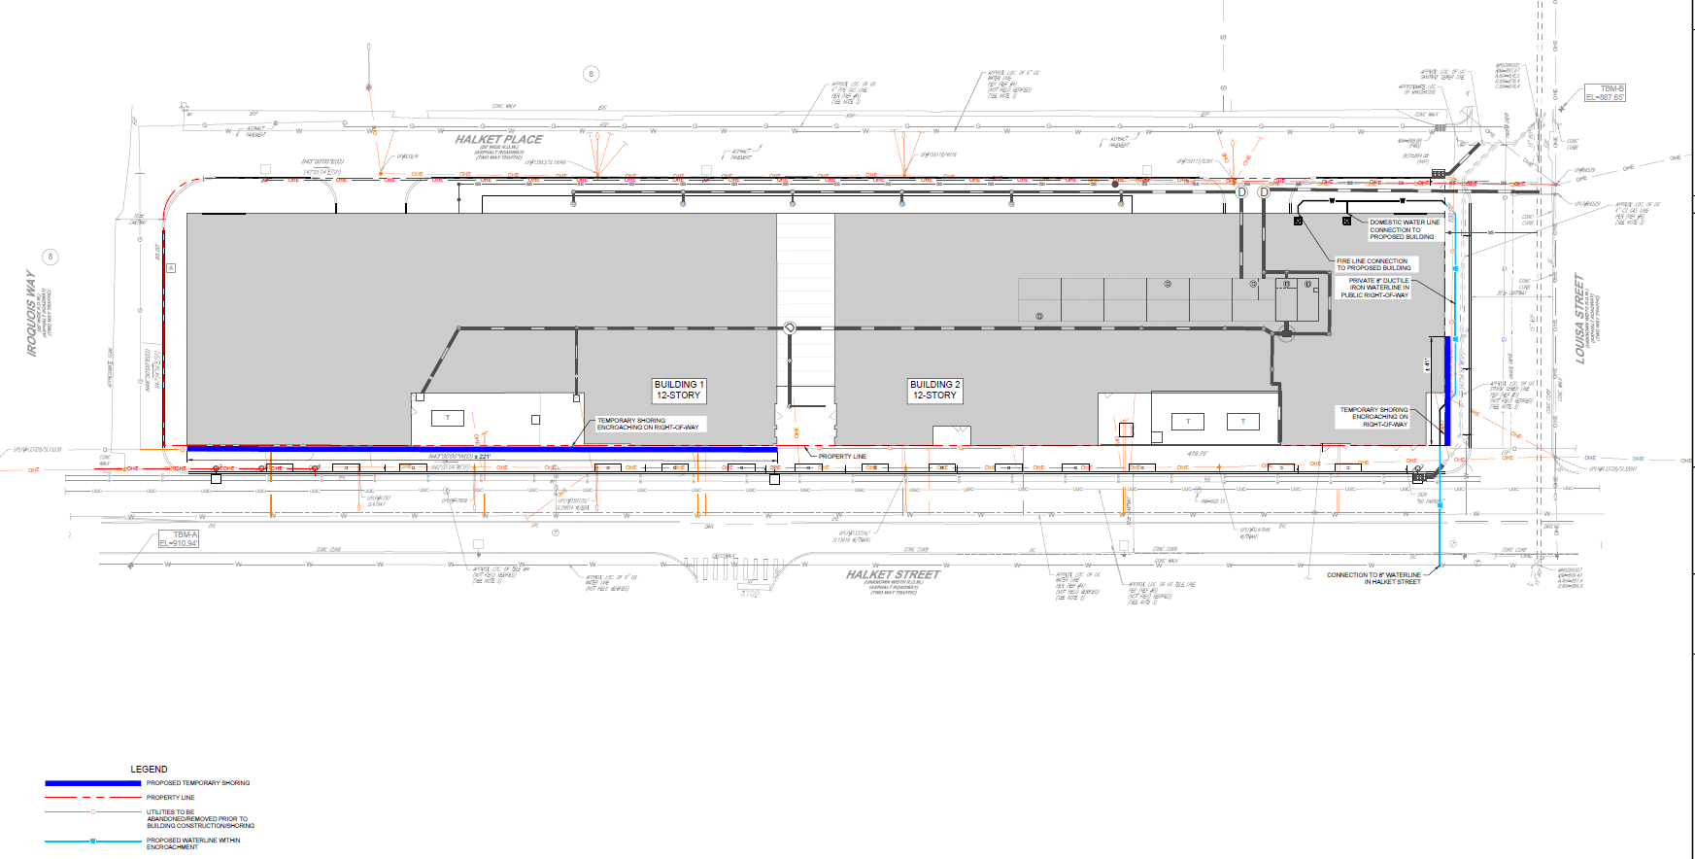

RECOMMENDATION:
DOMI staff’s recommendation is to approve this encroachment application.

