
CITY OF PITTSBURGH
Office of Management and Budget
William Peduto, Mayor Kevin Pawlos, Director

July 30, 2026

The Honorable President and Members of Council
5th Floor, City-County Building
414 Grant Street
Pittsburgh, PA 15219

Dear President and Members of Council:

Attached is a resolution further amending Resolution No. 796 of 2013, effective December 19, 2013, as amended, entitled “Resolution adopting and approving the 2014 Capital Budget and the 2014 Community Development Block Grant Program; and approving the 2014 through 2019 Capital Improvement Program,” by reducing BIRMINGHAM FOUNDATION by $7,365.46, increasing BIRMINGHAM FOUNDATION/BRASHEAR ASSOCIATION by $7,365.46, and authorizing a subsequent Agreement or Agreements.

Your favorable consideration of the Resolution is requested.

Sincerely,
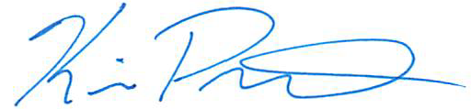

Kevin Pawlos
Director, Office of Management & Budget

Attachments

526 CITY-COUNTY BUILDING 414 GRANT STREET PITTSBURGH, PENNSYLVANIA 15219
www.pittsburghpa.gov

