August 18,2025

President and Members
City Council
City of Pittsburgh

Dear President and Members:

We submit for your consideration a Resolution authorizing the Mayor and Department of Parks and Recreation to enter on behalf of the City of Pittsburgh into an agreement or agreements with Allegheny County, Department of Human Services, for the City’s operation of its Senior Community Centers. Said agreement or agreement shall be for a term of one year at no cost to the City with compensation to the City not to exceed SEVEN HUNDRED EIGHTY FIVE THOUSAND and SEVEN HUNDRED NINE DOLLARS and NO CENTS ($785,709.00).

Your favorable consideration of this resolution is hereby requested.

Very truly yours,
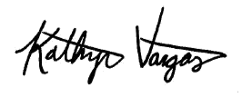
Kathryn Vargas
Director

KV/LH

Attachment

