May 11, 2026

The Honorable President and Members of Council
City County Building, 5th Floor
Pittsburgh, PA 15219

Dear President and Members of Council:

Attached is a proposed resolution authorizing the Mayor, the Director of the Office of Management and Budget, and the Director of the Department of City Planning to enter into an Agreement or Agreements with the Trust for Public Land for the purpose of receiving grant funds in the amount not to exceed TWENTY-FIVE THOUSAND ($25,000.00) dollars to acquire privately owned tax-delinquent land to improve connectivity of our greenways.

Your favorable consideration of this proposed Resolution is appreciated.

Sincerely,

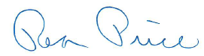

Rea Price
Acting Director

