May 5, 2026

The Honorable President and Members of Council
City County Building, 5th Floor
Pittsburgh, PA 15219

Dear President and Members of Council:

Attached is a proposed resolution authorizing the Mayor, the Director of the Office of Management and Budget, and the Department of Public Safety to enter into an Agreement or Agreements with the National Association of County and City Health Officials for the purpose of receiving grant funds from the Post Overdose Training in Trauma-Informed Practices in the amount not to exceed TWENTY-FIVE THOUSAND ($25,000.00) dollars for training and support of the City’s Office of Community Health and Safety.

Your favorable consideration of this proposed Resolution is appreciated.

Sincerely,

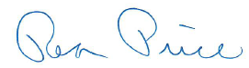

Rea Price
Acting Director

