June 26, 2026

The Honorable President and Members of Council
5th Floor, Pittsburgh City-County Building
414 Grant Street
Pittsburgh, PA 15219

Dear President and Members of Council,

Please find attached for your consideration a resolution authorizing the Mayor, on behalf of the City of Pittsburgh, to enter into an agreement or agreements or amendments thereto, with LA28 for coordination of events related to The LA28 Olympic and Paralympic Games at no cost to the City.

Your favorable consideration is requested.

Sincerely,
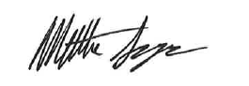

Matt Singer
Deputy Chief of Staff
Office of the Mayor

