May 19, 2026

The Honorable President and Members of Council
5th Floor, City County Building
414 Grant Street
Pittsburgh, PA 15219

Dear President and Members of Council:

This Communication is being forwarded to Council per § 219.04 of the City’s Code of Ordinances.
Attached is the Quarterly Financial & Performance Report for the Period Ending March 31, 2026.
Sincerely,
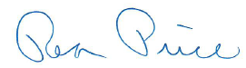
Rea Price
Acting Director

