May 15, 2026

The Honorable President and Members of Council
5th Floor, Pittsburgh City-County Building
414 Grant Street
Pittsburgh, PA 15219

Dear President and Members of Council,

Please find attached for your consideration an ordinance amending the Pittsburgh Code of Ordinances, Title Two: Fiscal, Article I: Administration, Chapter 218: Capital Budget and Capital Improvement Plan, to clarify language to better align with budgetary practices.

Your favorable consideration is appreciated.

Sincerely,
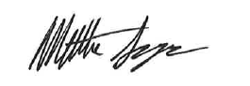

Matt Singer
Deputy Chief of Staff
Office of the Mayor

