September 12, 2024

President and Members of Council
City of Pittsburgh
City Council Chambers
520 City-County Building
Pittsburgh, Pennsylvania 15219 – 2464

Dear President and Members of Council:

Please find enclosed for your consideration a Resolution authorizing the issuance of a warrant as part of a settlement in favor of Rita Porterfield not to exceed $15,000.00

The funds are chargeable to and payable from the Professional Services line item in our 2024 operating budget, J.D. Edward codes as follows: 1050000.58105.00

Please let me know if you have any questions or concerns.

Sincerely,
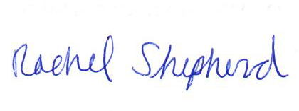
Rachel Shepherd
Executive Director

Enclosures

