
The City of Pittsburgh Department of Mobility & Infrastructure

STAFF MEMO

TO: Jeff Skalican, Director

FROM: Jen Massacci, Principal Planner

CC: Katie Wettick, Senior Right-of-Way Manager

RE: DOMI-EN-2026-00861 – Railroad Street

DATE: 5/17/2026

APPLICANT: Bradyn Schwabenbauer on behalf of MI STRIP WORKS LLC
REQUEST TO ENCROACH:
BRICKWORKS TOWNHOMES is requesting permission private sanitary sewer and (5) private sewer manholes to be located within Railroad Street.

DOMI REVIEW:
The proposed development is for 228 apartment units and 60 for-sale townhomes and condominiums. The proposed private water line has been designed in accordance with Pittsburgh Water and Allegheny County Plumbing standards and will not interfere with any public utilities identified on the existing conditions survey.

There are multiple site-specific and infrastructure-related constraints that necessitate the proposed encroachment into the public right-of-way. There is no sewer main located within the Railroad Street right-of-way; therefore, sanitary service must be provided via private conveyance to a tap in either 21st or 23rd Streets. It was also confirmed by Pittsburgh Water that the existing main bifurcating the site within the former 22nd Street right-of-way is not to be utilized for either a storm or sanitary sewer connection. Due to the lack of available sewer connections on Railroad Street, the prohibition of connecting to the 22nd Street sewer line, the existing utility conflicts requiring code-mandated separations, large underground stormwater detention facility running laterally across the site, and the previously approved site layout, routing the main entirely within private property is not feasible while maintaining adequate fall and required clearances from other utilities. The current alignment has been vetted during prior discussions with DOMI representatives and represents the only technically compliant and practical constructible solution. Additionally, the proposed private main does not interfere with public utilities identified on the existing conditions survey.

Utility Clearance: All utilities have signed off with no objections.

Legislation:
LEGISLATION.docx
Interdepartment Memos:
Notification was sent for approval on 5/12/2026
Approvals/No Objection returned on:
- Finance- Applicant to apply for new business registration prior to Finance approving
- Law’ Response- N/A
- DPW- 5/21
- PLI-
- Planning – 5/20
- Zoning- BDA-2025-12749 - In review – No objections on 5/20
Traffic Review – None
Utility Review - All utilities approved

PHOTO 1: Areial view of proposed location
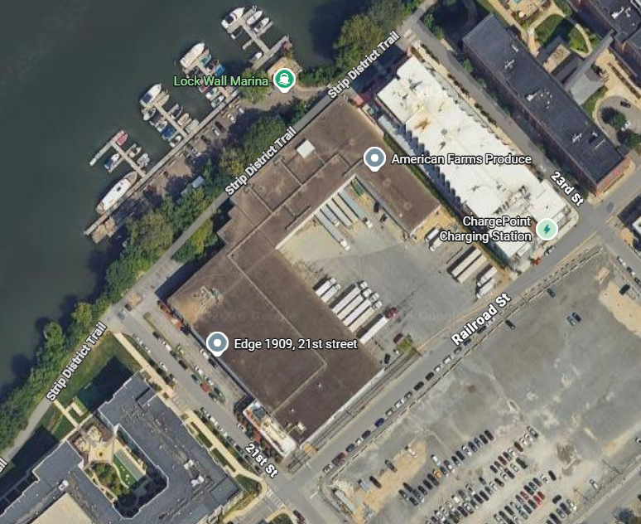

Photo 2: Encroachment plan
Pages from Application - Railroad St.pdf
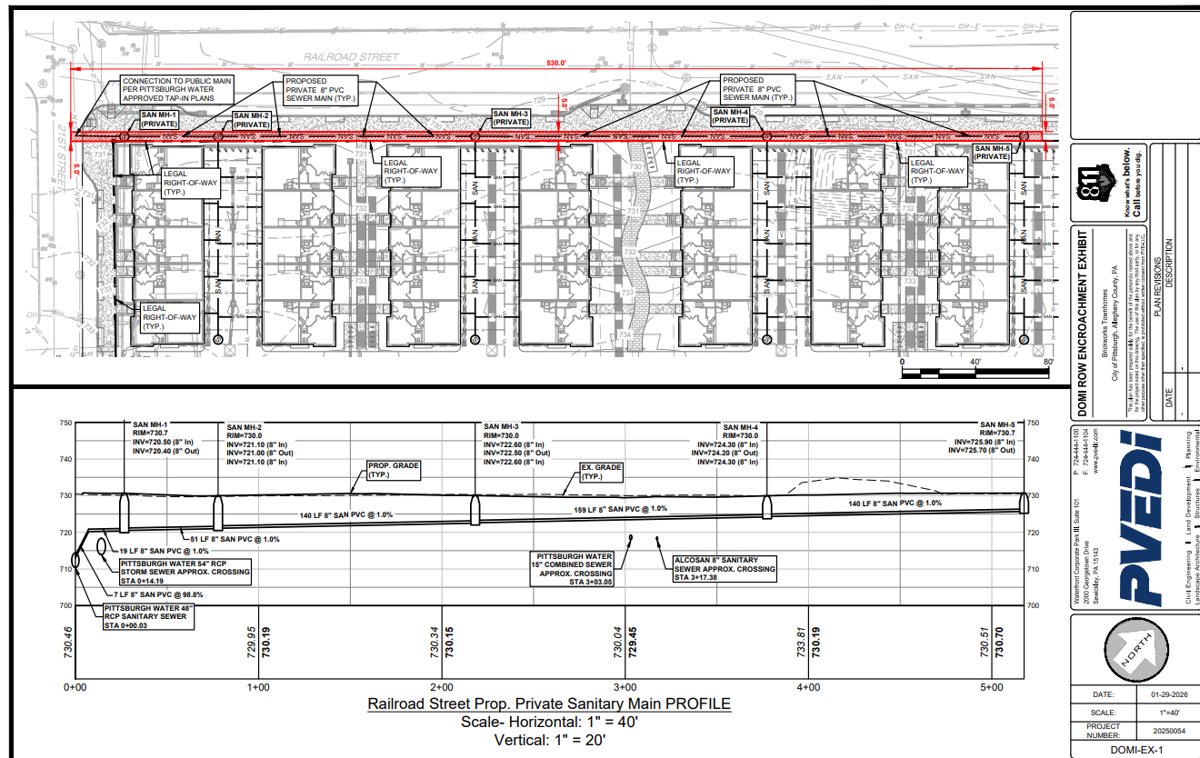

Photo 3: Building rendering
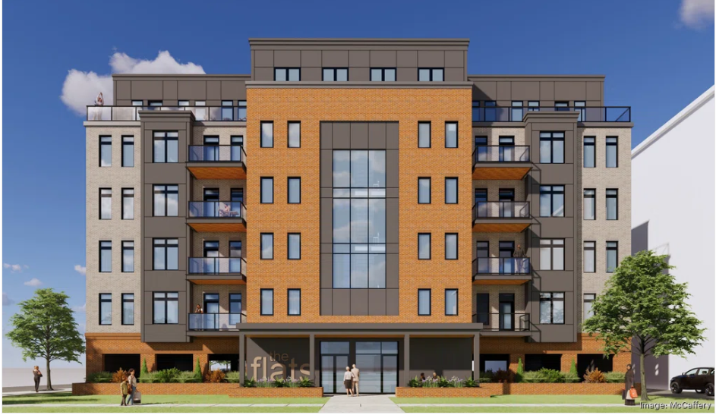

RECOMMENDATION:
DOMI staff’s recommendation is to approve this encroachment application.

