July 7, 2025

The Honorable President and Members of City Council
5th Floor, City County Building
414 Grant Street
Pittsburgh, PA 15219

Dear President and Members of Council:

Please find enclosed for your consideration a Resolution authorizing the Mayor and Director of the Department of City Planning to enter into a Professional Services Agreement or Agreements with Christine Davis Consultants, Inc. in an amount not to exceed Forty-Nine Thousand Six Hundred Dollars ($49,600) over one (1) year to provide archaeological services to Westinghouse Park, chargeable and payable from account number 4550020624- Westinghouse Park- Archaeology Study (2024 Parks Tax).

If you have any questions, please contact me or Isabella Gross, Principal Planner, at Isabella.Gross@pittsburghpa.gov.

Your favorable consideration is appreciated.

Sincerely,

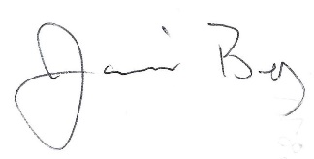

Jamil Bey, Ph.D.
Director of City Planning

Cc: file

