May 22, 2025
President and Members of Council
City of Pittsburgh
510 City-County Building
Pittsburgh, PA 15219

Dear President and Members,

Please find enclosed a Resolution authorizing the Mayor and the Director of Permits, Licenses, and Inspections, for the issuance of a warrant in favor of the National Fire Protection Agency (NFPA), at a cost not to exceed Eleven Thousand and Nine Hundred and Sixty-Four Dollars and Eighty-Four Cents ($11,964.84).

2025 $11,964.84 11101.130000.53.53301.2025
This request for warrant is for the purchase of supplemental NFPA building code books to be used by the Department of Permits, Licenses, and Inspections’ building code officers and officials. The NFPA is an International Code Council (ICC) Partner which establishes building codes that are adopted into state law and then locally adopted by the governing agencies.
PLI requests your favorable approval of this resolution.

Respectfully,
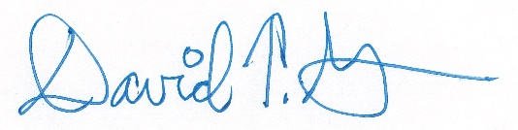
David Green
Director

