November 18, 2024

VIA EMAIL

President and Members of Council
City of Pittsburgh
City Council Chambers
520 City-County Building
Pittsburgh, Pennsylvania 15219-2464

Dear President and Members of Council:

The Commission on Human Relations respectfully requests approval of a Resolution providing for a Professional Service Agreement or Agreements with Lewis Neatrour Consulting to provide strategic planning and training to the Commission.
The total cost of the proposed agreement, to be finalized and approved by the City’s Solicitor, will not exceed Fifteen Thousand ($15,000) over one (1) year. It shall be payable from the Commission’s General Fund, JD Edwards codes as follow for each year: 11101.105000.53.53901.
Please let me know if you have any questions or concerns.

Sincerely,
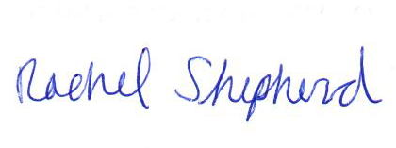
Rachel Shepherd
Director

Enclosures

