
EDWARD C. GAINEY CHRIS HORNSTEIN
MAYOR DIRECTOR

CITY OF PITTSBURGH

DEPARTMENT OF PUBLIC WORKS

CITY-COUNTY BUILDING

March 17, 2025

President and Members of City Council
City Council
RE: Warrant-United Rentals

Dear President and Members of Council:
Attached is a proposed resolution Providing for the issuance of a warrant in favor of United Rentals, in the amount of Thirty-Five Thousand Twenty-Five Dollars ($35,025.00), for the purpose of portable restroom rentals and servicing throughout the city’s parks system at various location; and providing for the payment of the costs thereof.
Funds are chargeable to and payable from the following Trust Fund account:
4000280070.56151.00
Due to this being in collections with the Law Department we are requesting a waiver of Rule 8.
Your favorable consideration of the attached proposed resolution is hereby requested.

Sincerely,

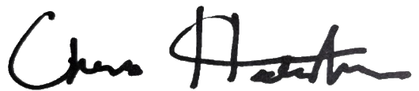

Chris Hornstein, RLA Department Director

CH/DM/JP

414 GRANT STREET | CITY-COUNTY BUILDING, THIRD FLOOR | 412-255-2586

